Azure Monitor



Monitoring and Dashboard

September 20, 2023

This document contains unpublished confidential and proprietary information of Odessa Technologies, Inc. No disclosure or use of any of these materials may be made without the express written consent of Odessa. ©1998-2020 Odessa Technologies, Inc. All Rights Reserved.

## Document revision history.

|  |  |  |  |
| --- | --- | --- | --- |
| Date | Description | Version | Author |
| 01/02/2023 | Azure Monitor Infra Health | 1.0 | Avinesh Gupta |
| 03/02/2023 | Added App Service availability | 1.0 | Satya & Pappu |
| 04/17/2023 | Added VM availability | 1.0 | Satya & Pappu |
| 06/19/2023 | Added Alerts for IIS stopped for Report Server VM | 1.0 | Pappu |
| 06/28/2023 | Updated Pre-Configuration Infra setup and required roles | 1.0 | Avinesh Gupta |
| 6/29/2023 | Updated DCR KQL queries for VM monitoring | 1.0 | Pappu Yadav |
|  |  |  |  |

Contents

Document revision history. 2

1. Overview 5

1.1 In-Scope 6

1.2 Out of Scope 6

1.3 Pre-configuration Infra Setup 7

1.4 Access/Roles Required 8

2. Odessa Logging & Monitoring Diagram 9

3. Logging Odessa Events 10

4. Type of Health/Infrastructure Events 10

5. Event Categories 10

6. Setting-up Infra Logging 11

6.1 Configure Application Insight 11

6.1.1 A step-by-step guide to configure application insights in Odessa core applications. 11

6.1.2 Configure Azure Dashboard & Alert Rules for Application Insights 13

6.1.3 Configure Availability Test 14

6.2 Configure Push Logs 16

6.2.1 Steps to create Push Logs 16

6.2.2 Configure Azure Dashboard 18

6.2.3 Configure Alert Rules (Execution Failure) 19

6.3 Configure VM Monitoring 20

6.3.1 Navigate to Azure VM for which you want to enable VM Insights. 20

6.3.2 Navigate to “Insights” and click on “Enable.” 20

6.3.3 Configure the Monitor using the configuration below. 21

6.3.4 Click on “Configure” (This will create Data Collection Rule for “Performance”) 21

6.3.5 Configure the “Processes and dependencies” using below snapshot, 22

6.4 Configure SQL MI Monitoring 22

6.4.1 Configure Diagnostic for Sending SQL Mi Logs 22

6.4.2 SQL MI Maintenance Alert Setup 25

7. Azure Infra Alert Configuration 27

7.1 App Services (Core, Report Builder) Alerts 30

7.1.1 Available Alerts 30

7.1.2 Common Action Groups 31

7.1.3 Custom Matching Conditions (CPU) 32

7.1.4 Custom Matching Conditions (Memory) 32

7.2 App Services (Partner Portal) Alerts 32

7.2.1 Available Alerts 32

7.2.2 Common Action Groups 34

7.2.3 Custom Matching Conditions (CPU) 34

7.2.4 Custom Matching Conditions (Memory) 35

7.3 SQL MI Alerts 35

7.3.1 Disk Space Shortage 35

7.3.2 CPU Consumption 36

7.3.3 Long Running Query 37

7.3.4 SQL MI Maintenance 38

7.4 Storage account Alerts 39

7.4.1 Available alerts 39

7.4.2 Common Action Groups 40

7.4.3 Custom Matching Conditions (Availability) 40

7.5 Key Vaults Alerts 40

7.5.1 Available alerts 40

7.5.2 Common Action Groups 41

7.5.3 Custom Matching Conditions (Availability) 41

7.6 Data Warehouse Maintenance Alerts 41

7.6.1 SQL Always-On Failure Alerts 41

7.6.2 Windows Failover Cluster Monitoring Alerts 42

7.6.3 Maintenance (VM Start & Stop) Alerts 43

7.6.4 Performance Alerts 44

7.6.5 Disk Shortage Space Alerts 47

7.6.6 SQL On VM Backup Failure Alerts 48

7.7 Report Server VM Alerts 49

7.7.1 Maintenance Alerts 49

7.7.2 Performance Alerts 50

7.7.3 Disk Shortage Space Alerts 52

7.7.4 VM IIS Service 53

8. Configure Metrics 54

8.1 App Service Plans 54

8.1.1 app-svc-plan-odessa-dev 55

8.1.2 app-svc-plan-odessa-pp-dev 56

8.2 SQL Managed Instance Metrics 58

8.2.1 Avg CPU Percentage. 59

8.2.2 Storage space used. 59

9. Configure Dashboard 60

9.1 Infrastructure Dashboard 60

9.1.1 Core & Shared (Report Builder, DWH & Report Server) 61

9.1.2 Partner Portal 65

9.1.3 Report Builder 67

9.2 Performance Dashboard 68

9.2.1 Core & Shared (Report Builder, DWH & Report Server) 70

9.2.2 Partner Portal 72

9.2.3 Report Builder 74

9.3 Logs Dashboard 75

9.3.1 Core 76

9.3.2 Partner Portal 77

9.3.3 Report Builder 79

10. Application Services - Health Check 80

10.1 App Service 81

10.2 API Service 81

10.3 Batch Jobs Service 82

11. Reference links 83

# 1. Overview

Azure monitor provides a comprehensive solution for collecting, analyzing, and responding to telemetry from the cloud-based environment.

This document explains Azure Infra Alerts, Metrics and Dashboards for Azure resources used for Odessa Application. Please refer the below table and referenced sections.

Azure provides a wide range of configurations and options to create distinct types of alerts, but this is not possible to cover everything. Odessa identifies most widely observable OOB alerts which have been configured same in HPE DEV environment within Azure portal. Moving forward as and when there is needed, HPE team can extend to create similar alerts/metrics in future.

|  |  |
| --- | --- |
| **Logging & Monitoring** | **Document Section** |
| Enabling Application Insight | Refer section 6.1 |
| Setting-up Push Log functions | Refer section 6.2 |
| Enabling VM Insights | Refer section 6.3 |
| SQL Mi Diagnostic Settings | Refer section 6.4 |
| Azure Infra Alerts | Refer section 7 |
| Azure Infra Metrics | Refer section 8 |
| Azure Infra Dashboards | Refer section 9 |

## In-Scope

* Push Logs setup within Function App
* Creating Alert rules for monitoring infra health
* Alert rules convers only Azure resources used by Odessa Applications
* Setting up monitoring dashboard for Odessa resources (Note - this covers OOB solution provided by Microsoft and observable metrics identified by Odessa)
* Alerting and Monitoring are configured only within HPE Azure DEV environment
* Providing list of monitoring azure resources used by Odessa applications and proposed required roles

## Out of Scope

* Setting up below listed Pre-Configuration infrastructure
* Sufficient IAM roles/permissions
* Azure resource creation
* Networking/VNET configuration
* Network connectivity between azure resources for Odessa Applications and monitoring azure services
* Identifying IAM roles for monitoring azure services

## Pre-configuration Infra Setup

This is assumed that following configurations/setup are available before configuring Odessa Push Log functions, creating alerts, and setting up monitoring dashboards.

|  |  |  |
| --- | --- | --- |
| **Application/Modules** | **Pre-Configuration** | **Notes** |
| Odessa Core, Report Builder, Partner Portal | Application Insight enablement | This has to be enabled for all sub-services of each application. This also includes all Odessa Core, Report Builder and Partner Portal Function Apps.  **Configure Application Insight to use correct Log Analytics Workspace.** |
| Odessa Core, Partner Portal, Report Builder | Function App creation | These function apps are used to setup PushLog function to fetch Odessa Logs from backed SQL DBs.  **Odessa Team deploys the PushLog function after Function App is provisioned by HPE.** |
| Report Server VM, Data Warehouse VM | VM Insight enablement | VM Insight is to be enabled for all nodes of each application |
| Odessa Core, Report Builder, Data warehouse, Report Server, Tvalue Service, Partner Portal | Log Analytics Workspace creation | A single log analytics workspaces is recommended to create |
| Report Server VM, Data Warehouse VM | Data Collection Rules | DCRs should be created for all node of each application and destination should be mapped to respective log analytics workspace |
| New relic function | New relic function creation | HPE must provide new-relic function to integrate with Alert rules for each environment |

## Access/Roles Required

Azure user should have the following access in HPE DEV environment –

|  |  |  |
| --- | --- | --- |
| **Azure**  **Resource** | **Resource Name** | **Action Required** |
| Application  Insights | * app-hpefs-odessa-apiserver-dev * app-hpefs-odessa-appserver-dev * app-hpefs-odessa-batchjobs-dev * app-hpefs-odessa-docportal-dev * app-hpefs-odessa-pp-apiserver-dev * app-hpefs-odessa-pp-appserver-dev * app-hpefs-odessa-pp-batchjobs-dev * app-hpefs-odessa-pp-docportal-dev * func-hpefs-odessa-core-log-insights-dev * func-hpefs-odessa-pp-log-insights-dev * func-hpefs-odessa-rb-log-insights-dev | User should be able to   * view metrics from Application Insights * create alert rules |
| Log Analytics  Workspace | * hpefs-log-analytics-workspace-dev | User should be able to   * view all triggered alerts * create alert rules * Modify alert rules * associate Action groups * configure threshold * delete alert rules * write KQL * view logs * Create metrics * Ping metrics to available and sharable dashboards |
| Function  Apps | * func-hpefs-odessa-core-log-insights-dev * func-hpefs-odessa-pp-log-insights-dev * func-hpefs-odessa-rb-log-insights-dev | User should be able to   * View PushLog function * Run sample test and view results |
| Dashboard  Access |  | User should be able to   * Modify dashboard * Add or delete metrics |
| Action Groups | * hpefs-odessa-dev-alerts-emailaction * ag-hpefs-newrelicalert-dev (new-relic function app) | User should have   * access to available Action Groups * associate with Alert rules |

# 2. Odessa Logging & Monitoring Diagram

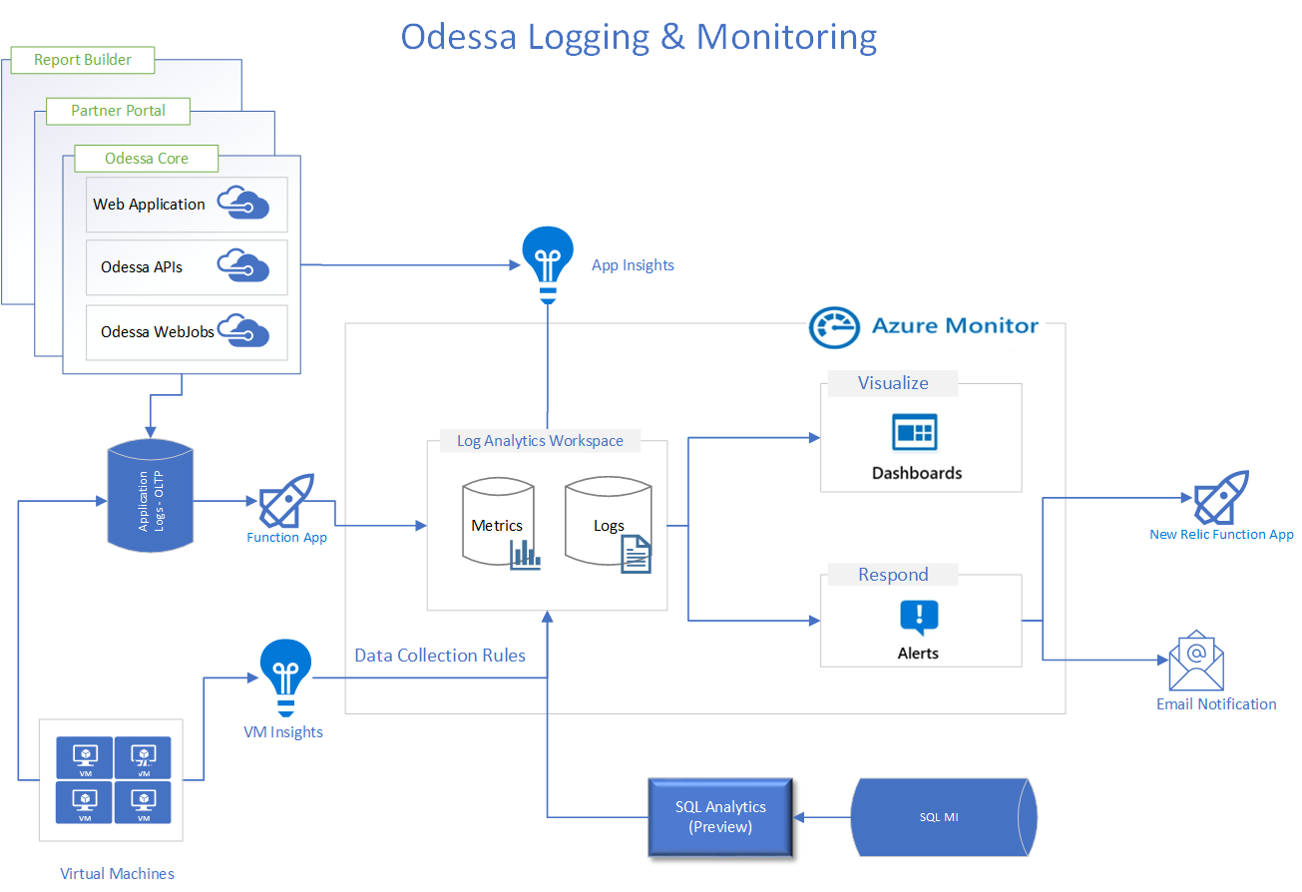

**Note:** SQL Analytics is a Preview version therefore Odessa is not recommending using this. Also, this document does not cover any solutioning for SQL Analytics tool.

# 3. Logging Odessa Events

Odessa services maintain application-based logs within databases. These logs are pushed to Azure Log Analytics in following two ways –

* Application Insights
* Azure Function App (Push Logs)

Virtual machine related events are pushed via VM Insights which is enabled within Azure.

# 4. Type of Health/Infrastructure Events

Azure provides a wide range of features to configure events for azure service health. This document provides some mostly usable events which are valuable to monitor for Odessa Applications. On a need basis, HPE can decide and extend the alerting.

The following three type of events have been covered –

* Availability
* CPU Consumption
* Memory Usages
* SQL Always On
* IIS service stopped
* Cluster Failover Manager

# 5. Event Categories

Events are categorized in the following three types –

* Application
* Health
* Infrastructure

A detailed list of all these events and alerts has been listed within the link below.

<https://hpe.sharepoint.com/:x:/r/sites/msteams_a09baa/_layouts/15/Doc.aspx?sourcedoc=%7B40d92b7e-8ff6-47c2-a143-e480904046cd%7D&action=edit&activeCell=%27MatchingConditions%27!C214&wdinitialsession=f4716a43-81fa-4342-a9b4-259dd641dfaf&wdrldsc=4&wdrldc=1&wdrldr=AccessTokenExpiredWarning%2CRefreshingExpiredAccessT>

# 6. Setting-up Infra Logging

## 6.1 Configure Application Insight

### 6.1.1 A step-by-step guide to configure application insights in Odessa core applications.

Note: - Below steps will be same for partner portal and report builder as well.

#### 6.1.1.1 Navigate to Azure app services (“app-hpefs-odessa-appserver-dev”) and search for “application insights” under the “settings” section.

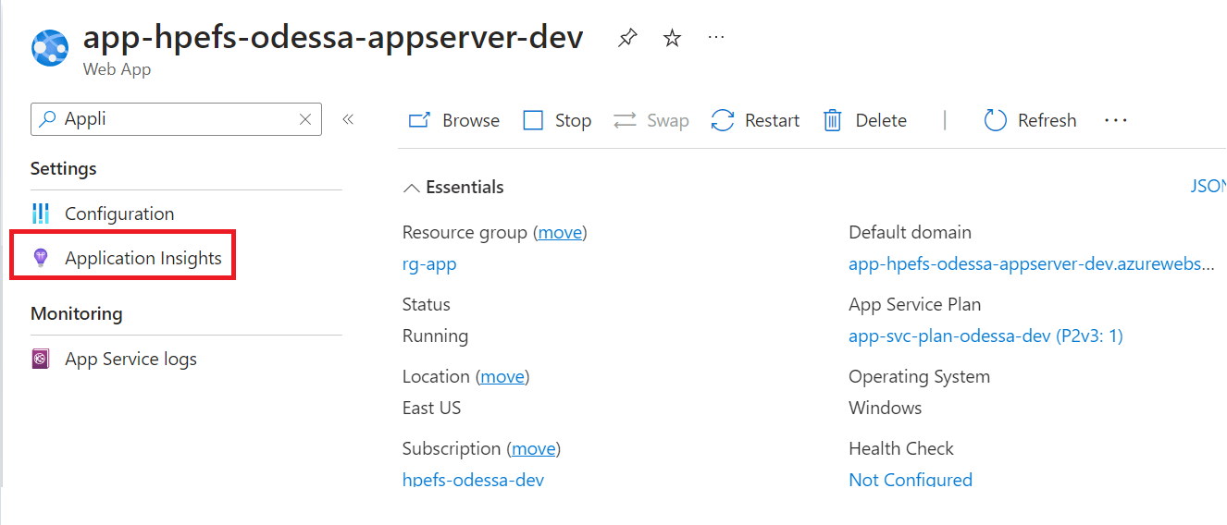

#### Enable application insights.

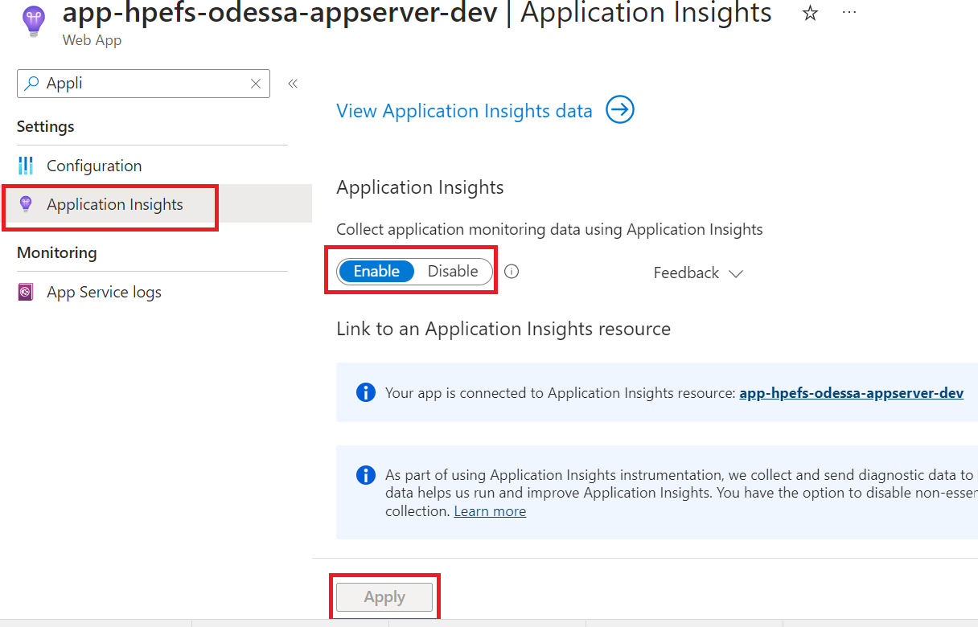

#### 6.1.1.3 Once application insights enabled click on “View Application Insights data” which will navigate to Application Insights, Copy “Instrumentation Key” and paste it under

1. For Odessa Core Web App -> Web.config -> “AzureAppInsightsInstrumentationKey”
2. For Odessa Core Web API -> Web.config -> “AzureAppInsightsInstrumentationKey”
3. For Odessa Core Windows Services -> Lw.WindowsServices.config -> “AzureAppInsightsInstrumentationKey”

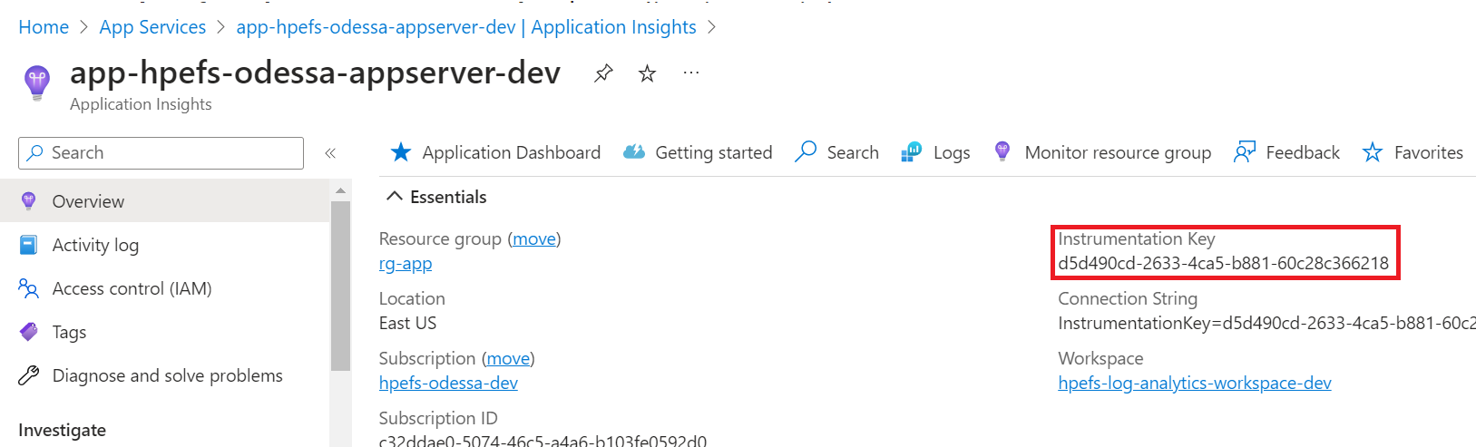

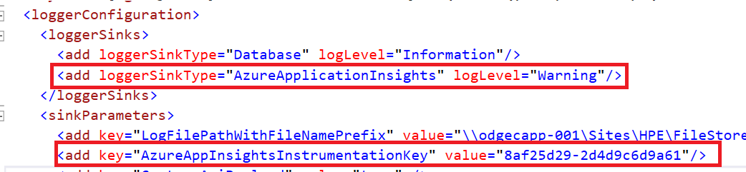

#### 6.1.1.4 Copy “Connection String” from application insights and paste it under

1. For Odessa core & API -> ApplicationInsights.config -> “ConnectionString”

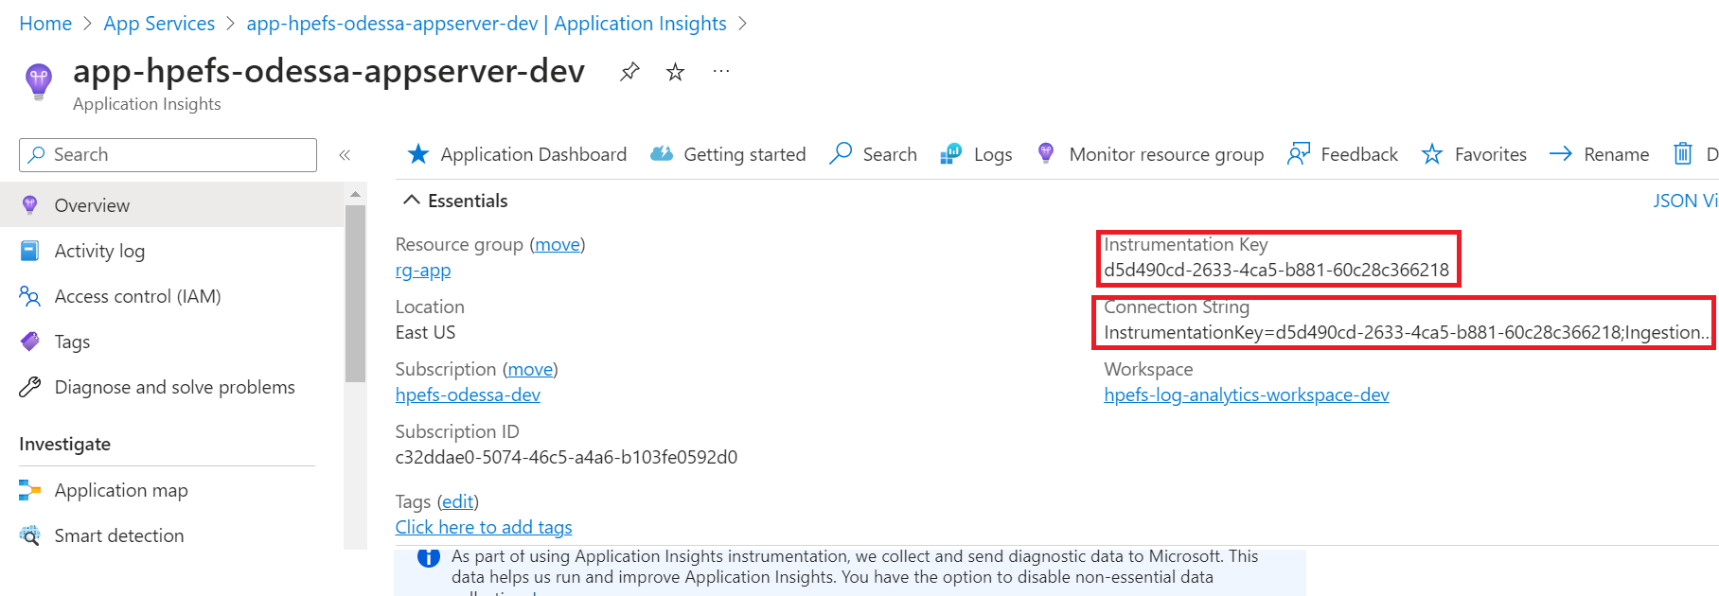

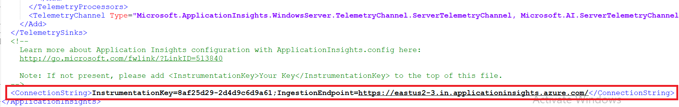

**Note:** Same steps need to be followed for Odessa Core Web API and Odessa Core Windows Services, we can make use of the same application insights or create new application insights for Web API and Windows Services.

### 6.1.2 Configure Azure Dashboard & Alert Rules for Application Insights

#### 6.1.2.1 Navigate to Azure application insights and search for “Logs” under the “Monitoring” section.

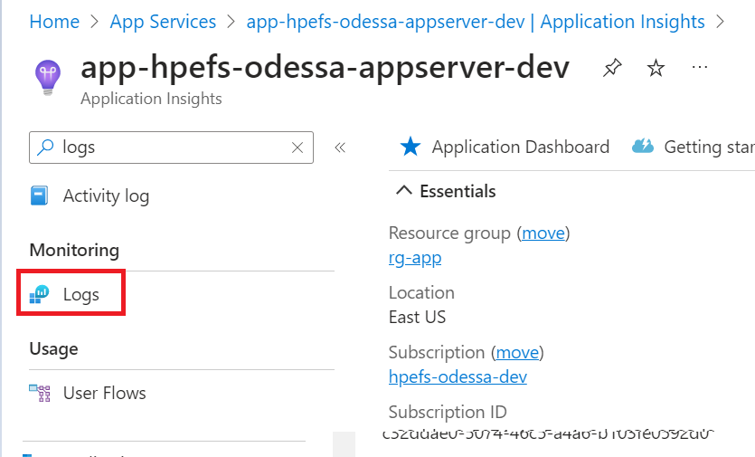

#### 6.1.2.2 Write a query using the “query templates” given below.

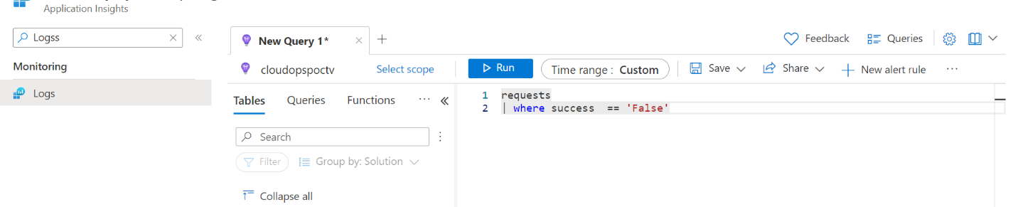

#### 6.1.2.3 Run results can be used to pin “Dashboard.”

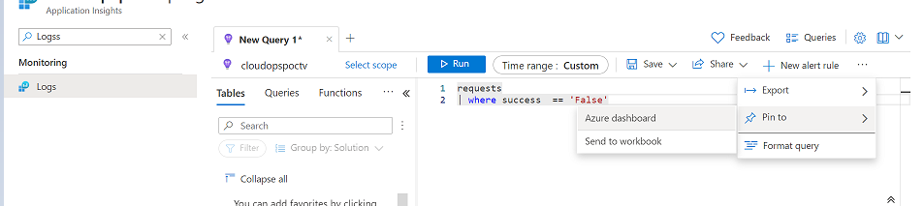

#### 6.1.2.4 Run result can be used to create an “Alert rule.”

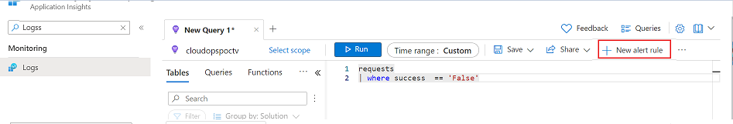

### 6.1.3 Configure Availability Test

#### 6.1.3.1 Navigate to Azure application insights and search for “Availability” under the “Monitoring” section.

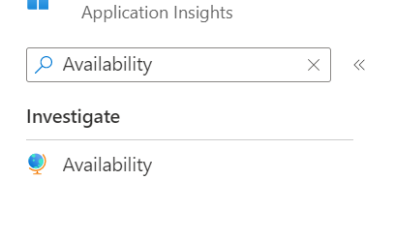

#### 6.1.3.2 Click on “Add standard test.”

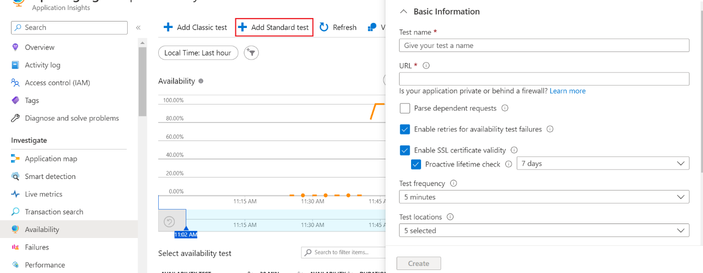

#### 6.1.3.3 Provide “Test name,” “URL” and choose “Test Locations.”

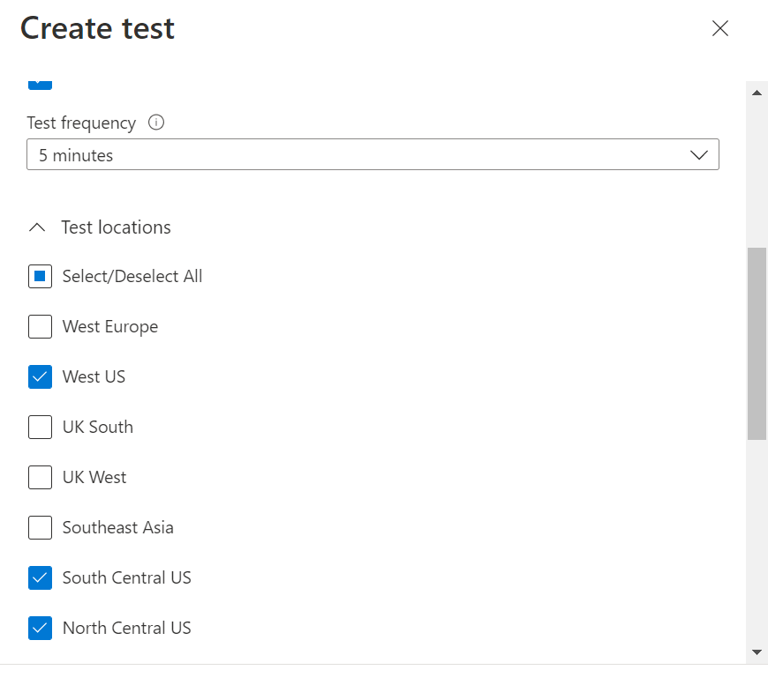

#### 6.1.3.4 Click on “Create” and update “Alert rules.”

For Odessa core test URL: “{ApplicationURL}**/Warmup**,” and for Odessa core API: “{APIApplicationURL}**/api/ping**”

success criteria as shown below,

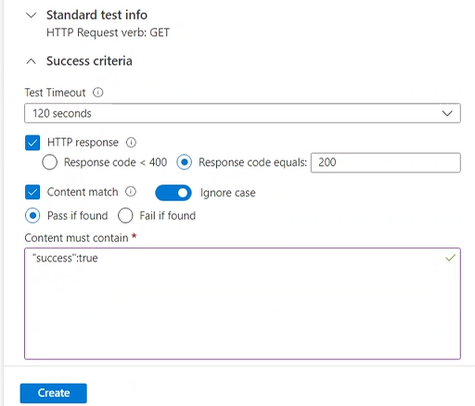

## Configure Push Logs

In the Odessa application, certain logs are not pushed to application insights through Odessa sink logger, these are custom logs and can be pushed using Push Logs function app.

### 6.2.1 Steps to create Push Logs

Function App Content Location:

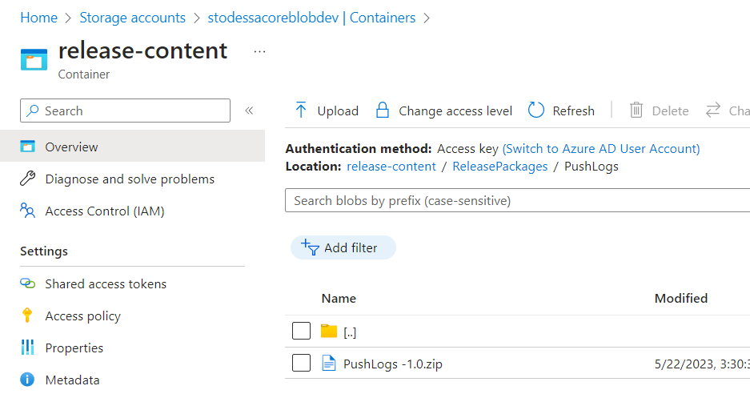

#### 6.2.1.1 Create a Function App, Integrate with V.NET for database connectivity.

#### Publish the code provided by Odessa into Function App using [Azure DevOps](https://odessatechnologies.sharepoint.com/sites/HPE/Shared%20Documents/Technical/Sizing%20%26%20Environments/Azure%20Monitor/Azure_FunctionAppDeployment.docx) or Visual Studio or Manually using SFTP credentials.

#### **6.2.1.3 Configuration:** Once the deployment is completed, below are the values that must be configured in the App settings of Function App

Navigate to the Configuration section of Function App as shown in the image below and click on + New application setting to add a new key.

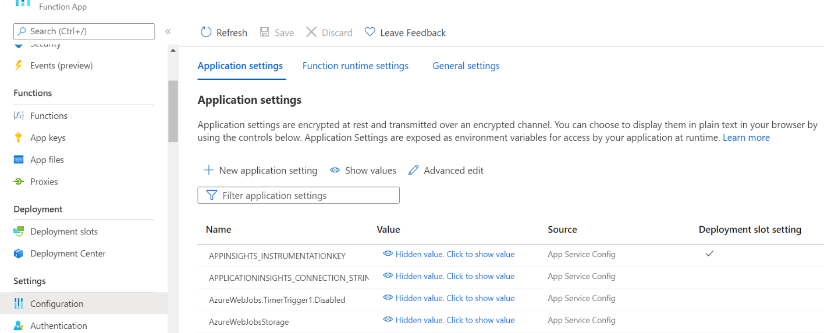

Provide the values for the below mentioned Keys:

1. **SqlConnectionString:** For instance: Server={Server Name};Initial Catalog={Database Name};Persist Security Info=False;User ID={User Name};Password={Password};MultipleActiveResultSets=False;Connection Timeout=30;
2. **LogAnalyticsSharedKey**& **LogAnalyticsWorkSpaceId:**These 2 keys can be found in the Agents Tab of the Log Analytics Workspace created as shown in the below snap:

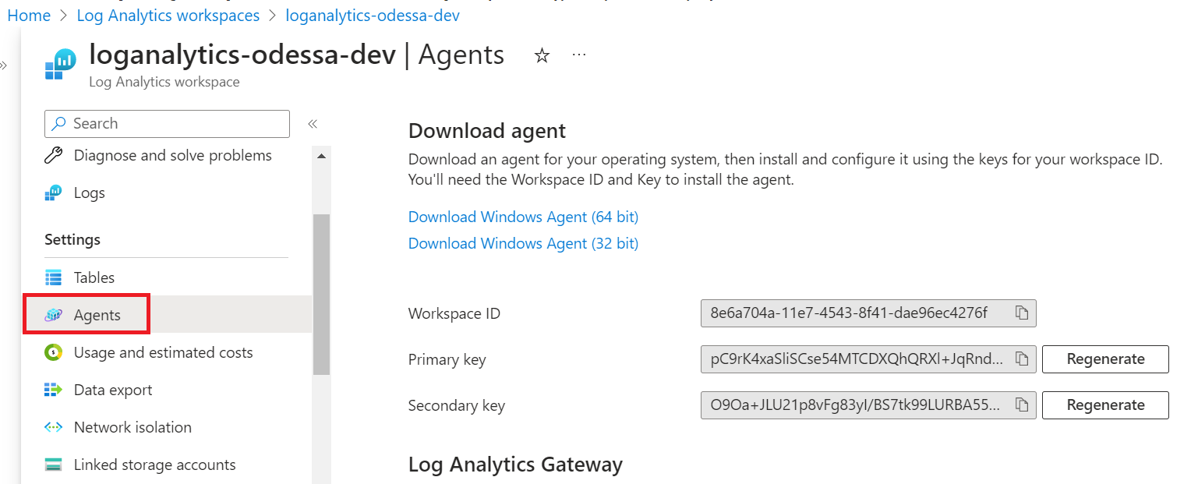

1. Create a V.NET integration within the function app for the function app and SQL VM to communicate.

#### **6.2.1.4 Testing:** Once the setup is done, evaluate the function app by following the below steps:

##### 6.2.1.4.1 Navigate to the Functions tab in the function app created.

##### 6.2.1.4.2 Select PushLogs function.

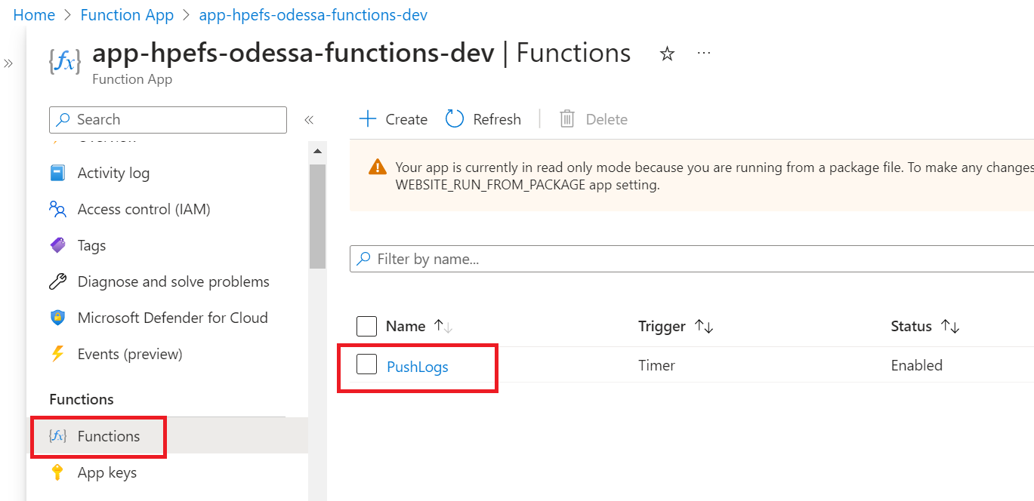

##### 6.2.1.4.3 Go to Code+Test Tab and click on the Test/Run option.

##### 6.2.1.4.4 The Function app should trigger, and it will push all the job logs into the LogAnalyticsWorkspace.

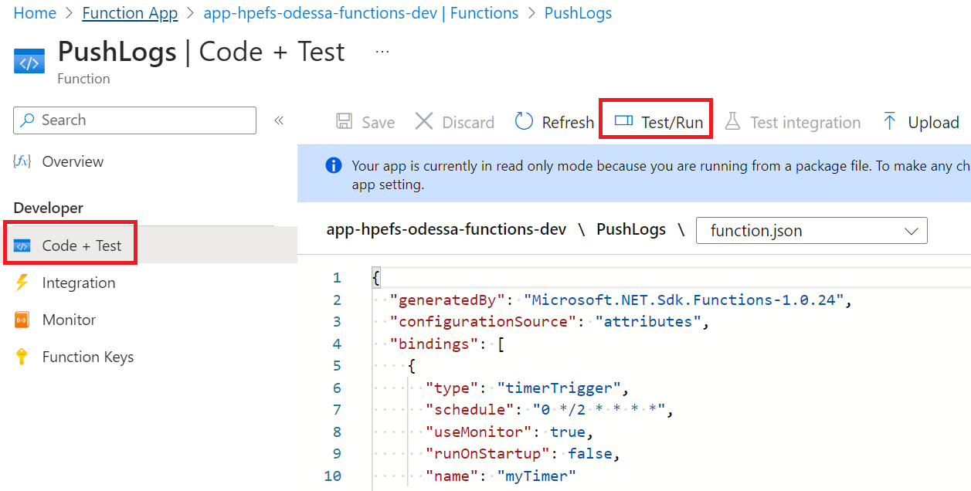

### 6.2.2 Configure Azure Dashboard

Further, the custom queries can be written on the tables and pin to the dashboard for monitoring as shown below:

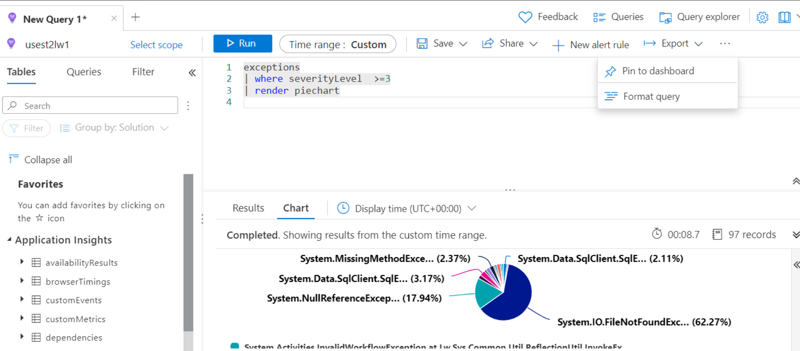

**Note:** The query can be pinned to the already existing dashboard, or we can create a new dashboard as shown in the image below:

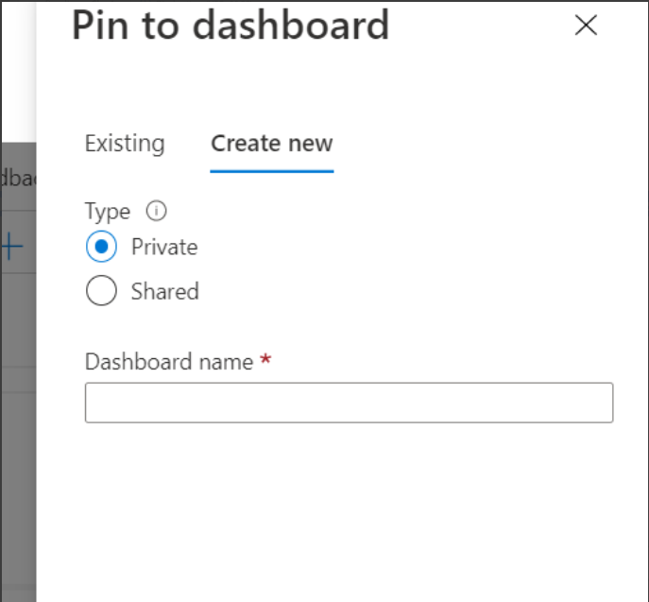

### 6.2.3 Configure Alert Rules (Execution Failure)

#### 6.2.3.1 Navigate to Function App -> Functions -> Push Logs.



#### 6.2.3.3 Select “PushLogs Failures” condition and configure as per below screenshot.

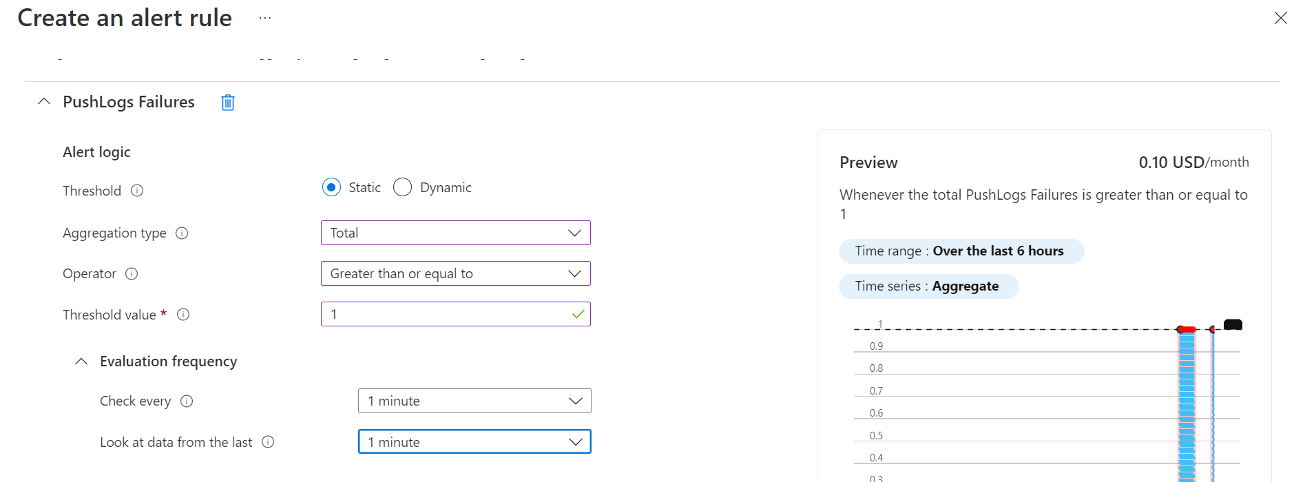

## 6.3 Configure VM Monitoring

We are using Azure monitor agent to monitor Azure VM’s.

Step-by-step guide:

### 6.3.1 Navigate to Azure VM for which you want to enable VM Insights.

### 6.3.2 Navigate to “Insights” and click on “Enable.”

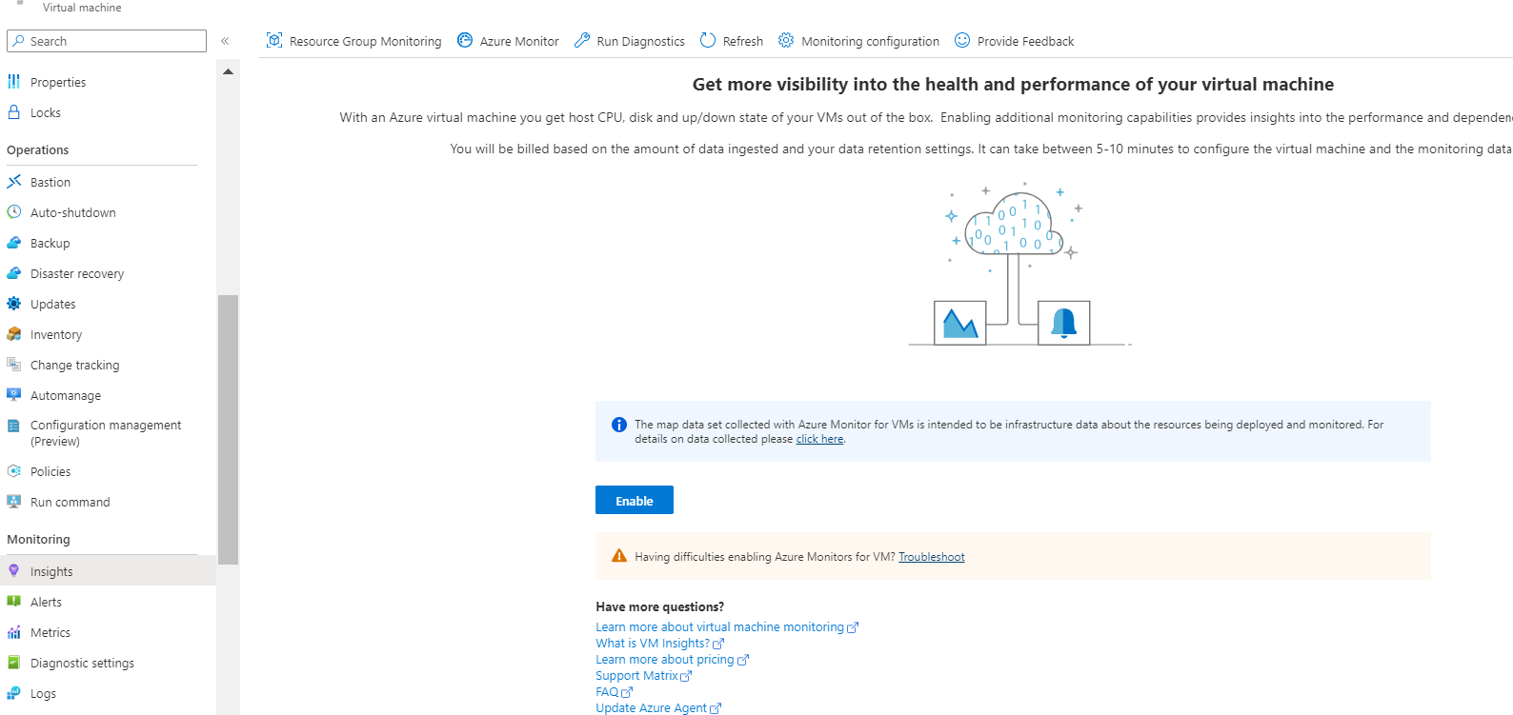

### 6.3.3 Configure the Monitor using the configuration below.

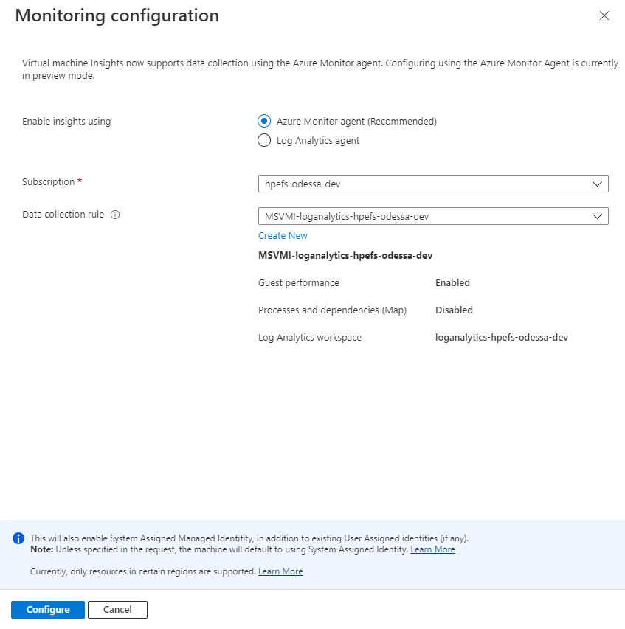

### 6.3.4 Click on “Configure” (This will create Data Collection Rule for “Performance”)

You can find the Data Collection Rule in Monitor.

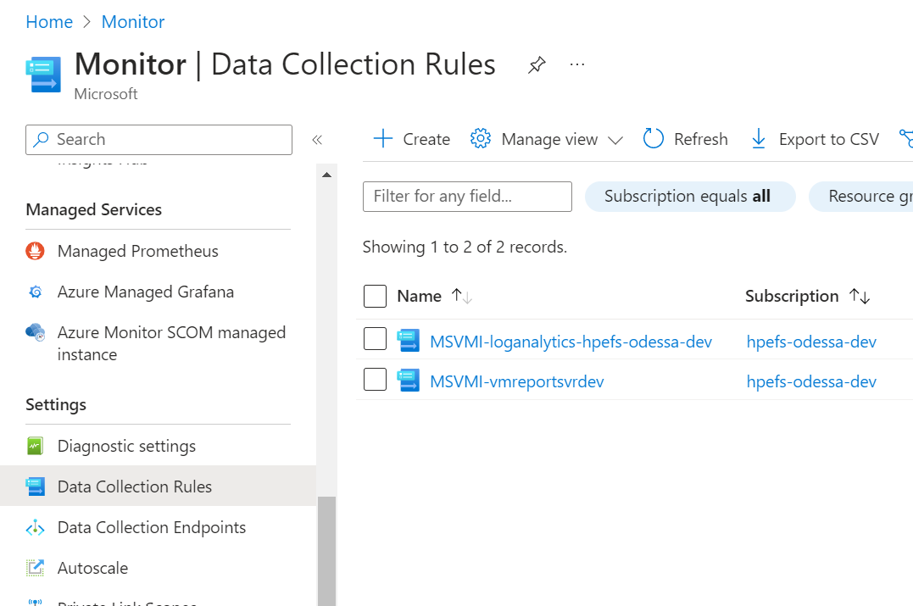

### 6.3.5 Configure the “Processes and dependencies” using below snapshot,

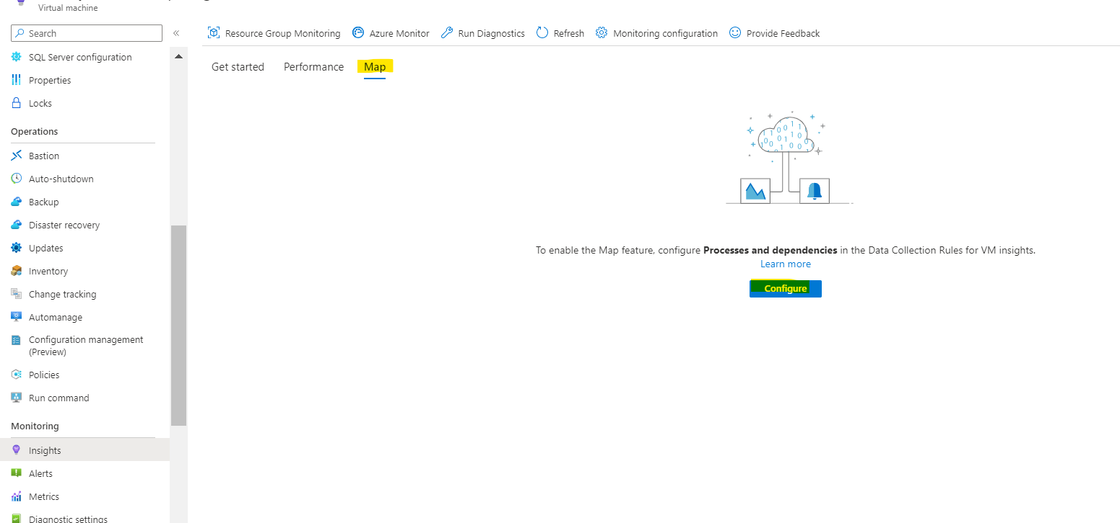

## 6.4 Configure SQL MI Monitoring

### 6.4.1 Configure Diagnostic for Sending SQL Mi Logs

Diagnostic settings for sending logs are configured at two levels as below –

1. SQL Mi Server Level
2. SQL Mi Database Level
3. **Server Level Logging Configuration**
4. Create a new resource “Azure SQL Analytics” solution. (During creation we need to associate it with Log Analytics workspace)
5. Navigate to SQL MI. In **Monitoring**, select **Diagnostic settings**.
6. Click on Add diagnostic settings.

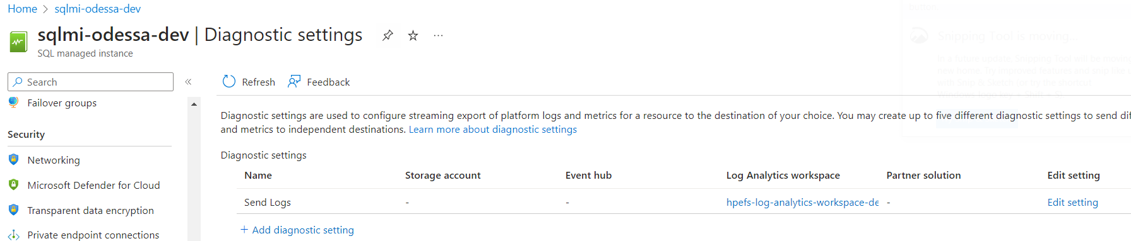

1. Select required options as shown below and click on **Save**.

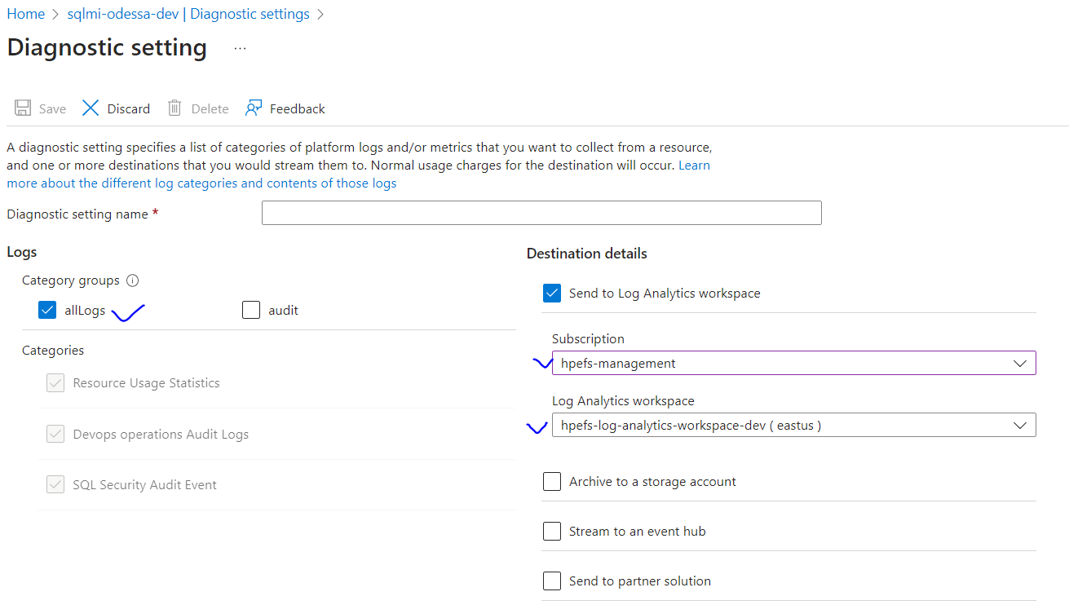

1. **Database Level Logging Configuration**
2. Navigate to Overview, search for Database on which user wish to configure “Diagnostic settings.”

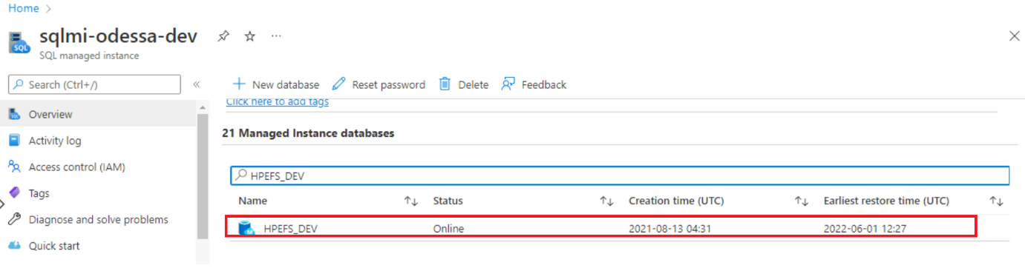

1. Navigate to Monitoring, select Diagnostic settings.
2. Click on Add diagnostic settings.

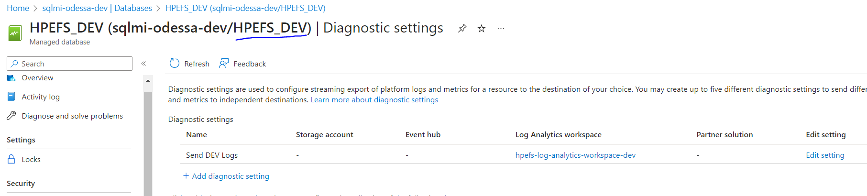

1. Select required options as shown below and click on Save.

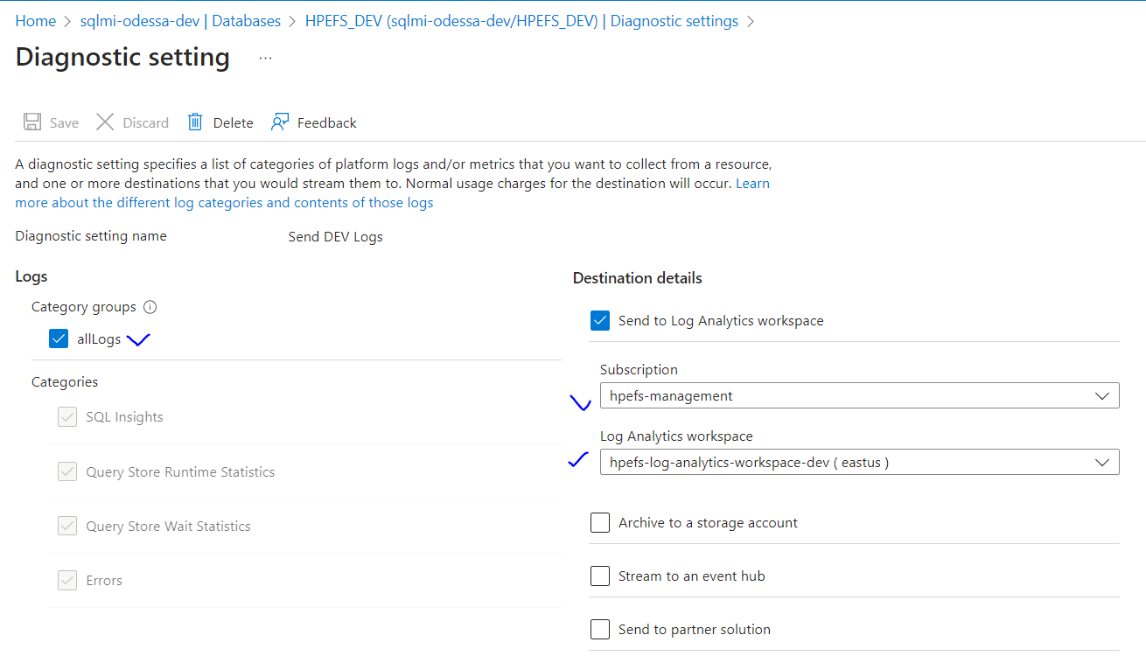

1. Navigate to “Log Analytics workspace,” and search for “Logs” under the “General” section.

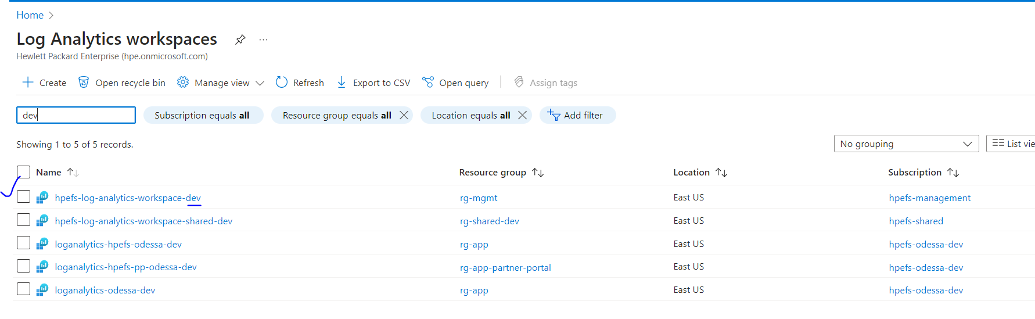

1. Type Azure Diagnostics within Query window and click on Run. SQL Mi logs will be shown as below.

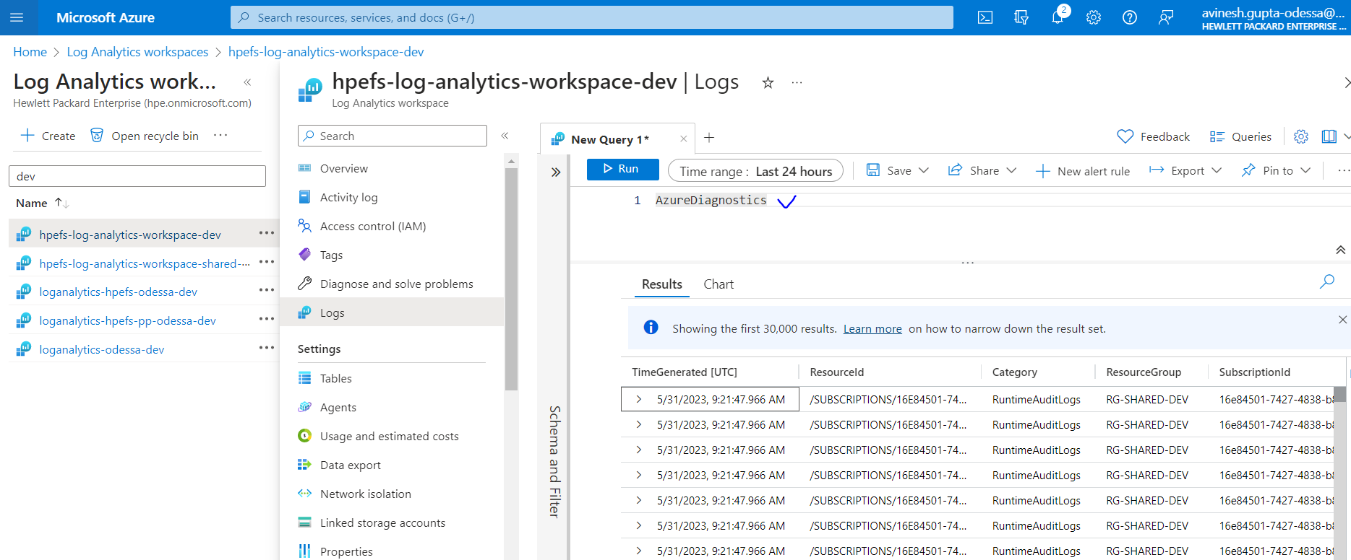

1. Write a query using the “query templates” given below.

Sample query to filter out DB level logs.

|  |
| --- |
| AzureDiagnostics  | where ResourceProvider == "HPEFS_DEV"  | where Category == 'QueryStoreWaitStatistics'  | parse _ResourceId with * "/microsoft.sql/servers/" LogicalServerName "/databases/" DatabaseName  | project  query_hash_s,  TimeGenerated |

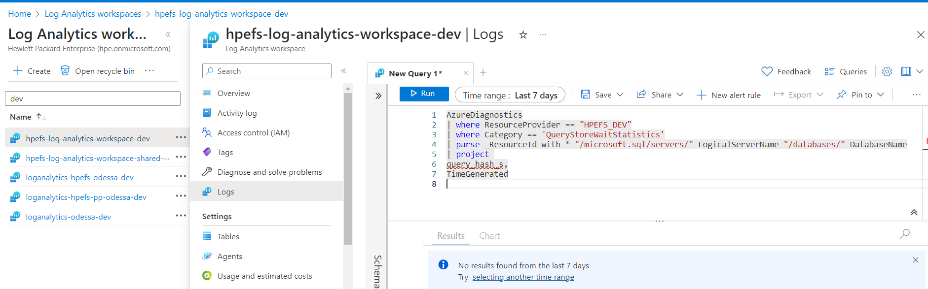

### 6.4.2 SQL MI Maintenance Alert Setup

Steps to configure the alerts.

1. Select the SQL MI and then search for maintenance

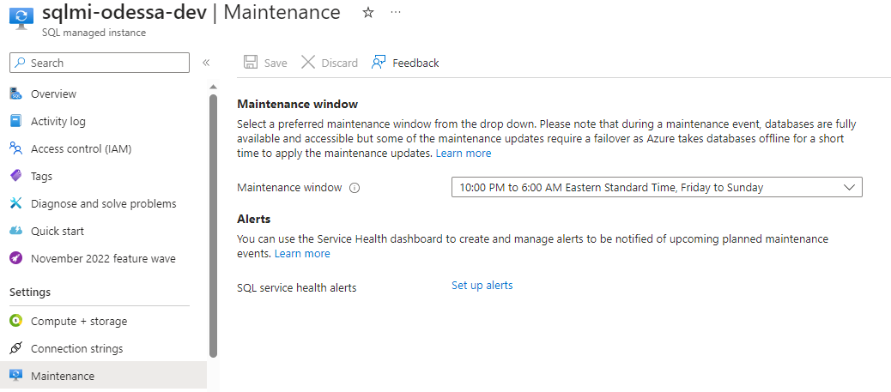

1. Click on Set up alerts.

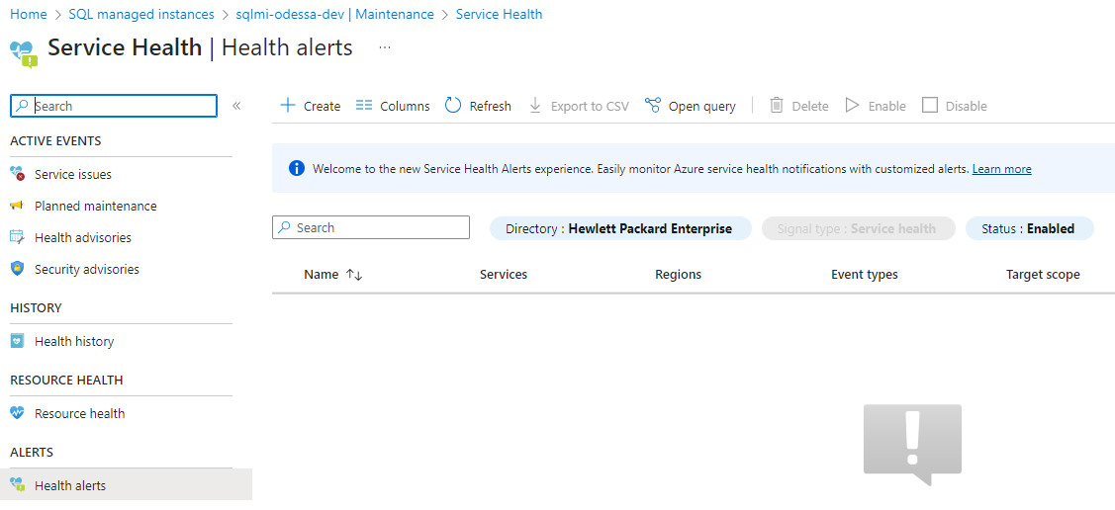

1. Create the alerts

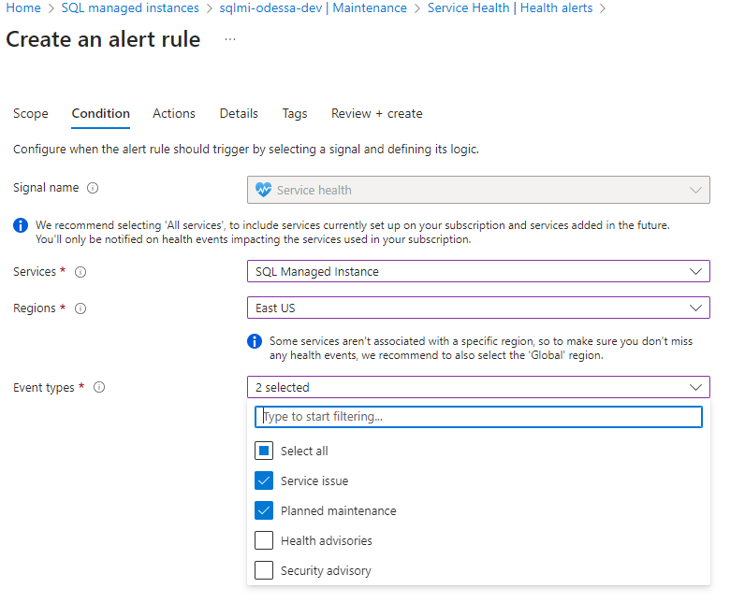

# 7. Azure Infra Alert Configuration

Available alerts for all the applications (Monitor -> Alerts -> Alerts Rules)

Alerts have been configured for the dev applications below.

* **App Services, SQL Mi, Storage Account, Key Vault Alerts**

|  |  |  |  |  |  |
| --- | --- | --- | --- | --- | --- |
| **Sr No.** | **Application/**  **Resources** | **Type** | **Service Name** | **Event Type** | **Instructions** |
| 1 | App Services (Core, Gold Config, Report Builder) | App Service Plan (app-svc-plan-odessa-dev) | **Core App Services**  app-hpefs-odessa-apiserver-dev  app-hpefs-odessa-appserver-dev  app-hpefs-odessa-batchjobs-dev  app-hpefs-odessa-docportal-dev  **Gold Config App Services**  app-hpefs-odessa-appserver-config  app-hpefs-odessa-batchjobs-config  **Report Builder App Services**  app-hpefs-odessa-reportbuilder-appserver-dev  app-hpefs-odessa-reportbuilder-batchjobs-dev | Availability, CPU, Memory | Refer 7.1 |
| 2. | App Services (Partner Portal) | App Service Plan (app-svc-plan-odessa-pp-dev) | app-hpefs-odessa-pp-apiserver-dev  app-hpefs-odessa-pp-appserver-dev  app-hpefs-odessa-pp-batchjobs-dev  app-hpefs-odessa-pp-docportal-dev | Availability, CPU, Memory | Refer 7.2 |
| 3. | SQL Mi | Database | [sqlmi-odessa-dev](https://portal.azure.com/#@hpe.onmicrosoft.com/resource/subscriptions/c32ddae0-5074-46c5-a4a6-b103fe0592d0/resourceGroups/rg-app/providers/Microsoft.Sql/managedInstances/sqlmi-odessa-dev) | 1. Avg CPU>85%,  2. Long Running Query more than 3 mins  3. Activity Log Alert for SQL Mi Start and Stop – (Recommended) | Refer 7.3 |
| 4. | Storage Account | Container | [stodessacoreblobdev](https://portal.azure.com/#@hpe.onmicrosoft.com/resource/subscriptions/16e84501-7427-4838-b8ab-70208b5e5565/resourceGroups/rg-shared-dev/providers/Microsoft.Storage/storageAccounts/stodessacoreblobdev) | Availability | Refer 7.4 |
| 5 | Key Vault | Secrets | [kv-hpefs-odessa-dev](https://portal.azure.com/#@hpe.onmicrosoft.com/resource/subscriptions/c32ddae0-5074-46c5-a4a6-b103fe0592d0/resourceGroups/rg-app/providers/Microsoft.KeyVault/vaults/kv-hpefs-odessa-dev) | Availability,  Secret near expiry (Blocked For HPE. Mani is working on POC) | Refer 7.5 |
|  |  |  |  |  |  |

* **Data Warehouse Maintenance Alerts**

|  |  |  |  |  |
| --- | --- | --- | --- | --- |
| **S.No.** | **Environment.** | **Scenario** | **Event Type (Short Desc of Alert)** | **Reference/Instructions** |
| 1. | STG  VM Name - Vmdatamartstg1, Vmdatamartstg2 | SQL Always on Failure | SQL Always on Failure, | Refer 7.6.1 |
| 2 | STG  VM Name - Vmdatamartstg1, Vmdatamartstg2 | Windows Failover Cluster Monitoring | Windows Failover  Cluster Monitoring | Refer 7.6.2 |
| 3. | DEV  VM Name - vmdatamartdev | **VM Maintenance Alerts –**  (Security Patching/Win Upgrade or any others) causes VM restart. | VM Events (VM restart, VM stop) Count > 1 | [Refer 7.6.3](#_7.6.3_Maintenance_(VM) |
| 4. | DEV  VM Name - vmdatamartdevv | **Performance –**  Availability, High CPU Usage, High Memory Consumption | 1. Availability (Avg >=85%) 2. High CPU (Avg >=85%) 3. High Memory (Avg >=85%) | Refer 7.6.4 |
| 5. | DEV  VM Name - vmdatamartdev | Disk Shortage space | 1. OS Disk Space Consumption (Avg >=85%) 2. Data Disk Space Consumption (Avg >=85%) | <https://www.serverless360.com/blog/avoid-downtime-with-azure-vm-disk-space-alerts-best-practices>  Refer 7.6.5 |
| 6 | DEV  VM Name - vmdatamartdev | SQL On VM Backup Failure | Count >= 1 | Refer 7.6.6 |

* **Report Server VM Alerts**

|  |  |  |  |  |
| --- | --- | --- | --- | --- |
| **S.No.** | **Environment** | **Scenario** | **Event Type** | **Reference/Instructions** |
| 1. | DEV  VM Name - vmreportsvrdev | **VM Maintenance** (Security Patching/Win Upgrade or any others)  Causes VM restart | VM Events (VM restart, VM stop) Count > 1 | Refer 7.7.1 |
| 2. | DEV  VM Name - vmreportsvrdev | **Performance Alerts**  Availability, CPU & Memory | 1. Availability (Avg >= 85%) 2. High CPU (Avg >=85%) 3. High Memory: (Avg >= 85%) | Refer 7.7.2 |
| 3. | DEV  VM Name - vmreportsvrdev | Disk space | 1. OS Disk Space Consumption (Avg >=85%) 2. Data Disk Space Consumption (Avg>=85%) | <https://www.serverless360.com/blog/avoid-downtime-with-azure-vm-disk-space-alerts-best-practices>  Refer 7.7.3 |
| 4. | DEV  VM Name - vmreportsvrdev | IIS Stopped  (Coverage – TValue and RB Report Generation services hosted within IIS) | IIS Service Stopped (Count > 1) | Refer 7.7.4 |

## 7.1 App Services (Core, Report Builder) Alerts

Core and Report builders use common App service plan. The below alerts monitor CPU and memory usages for all these services.

### 7.1.1 Available Alerts

* CPU Percentage
* Memory Percentage
* Availability

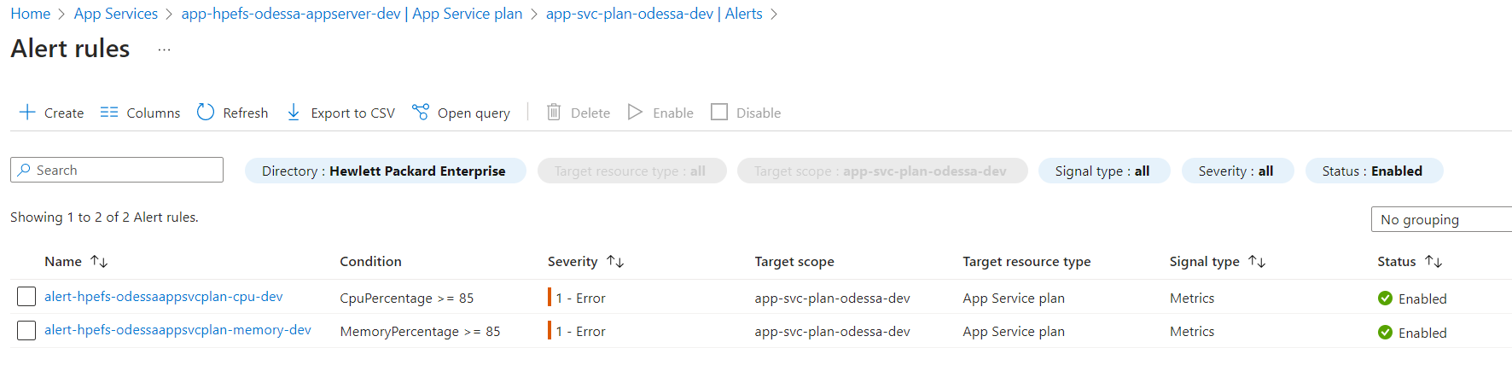

**Core App Service**

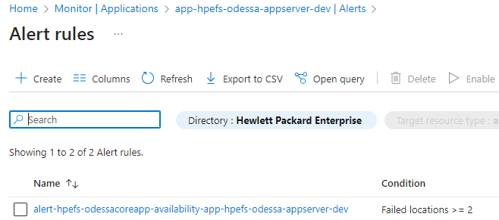

**Core API Service**

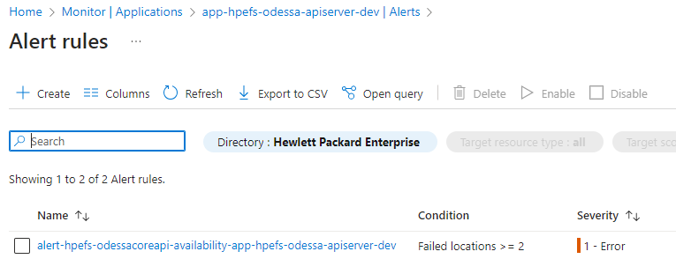

**Core Batch Jobs**

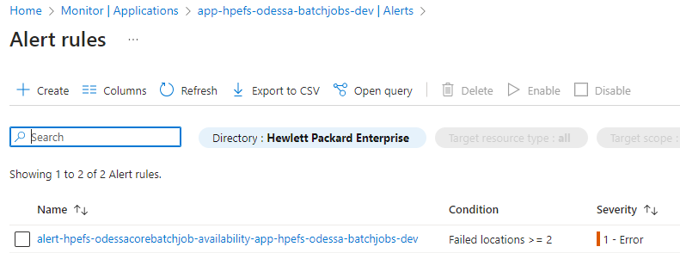

### 7.1.2 Common Action Groups

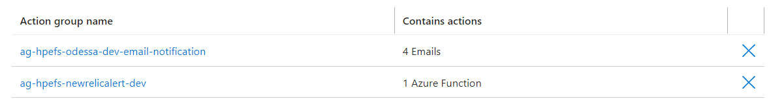

### 7.1.3 Custom Matching Conditions (CPU)

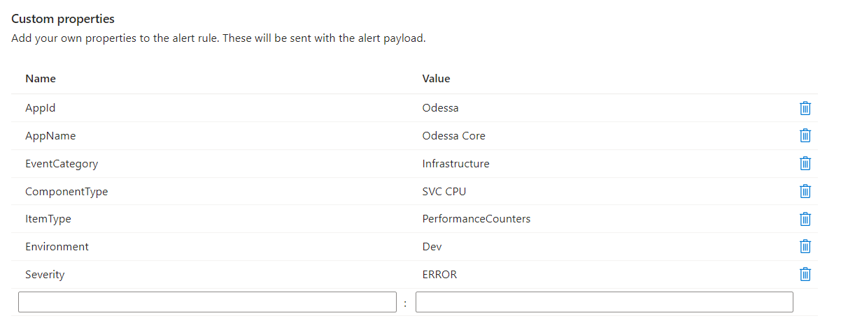

### 7.1.4 Custom Matching Conditions (Memory)

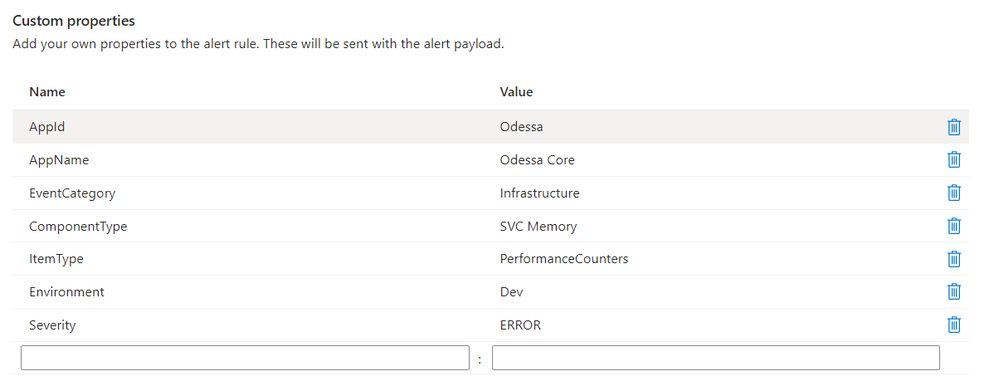

## 7.2 App Services (Partner Portal) Alerts

List of alerts created for the core app service.

### 7.2.1 Available Alerts

* CPU Percentage
* Memory Percentage
* Availability

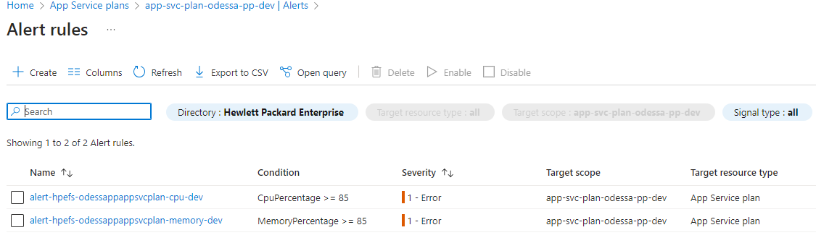

**PP App Service**

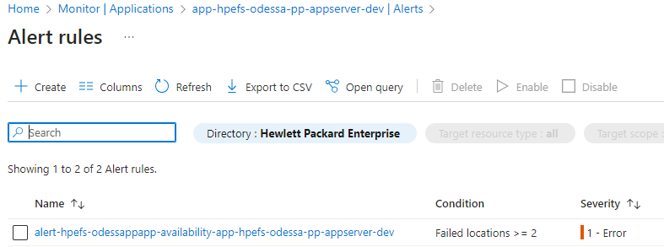

**PP Api Service**

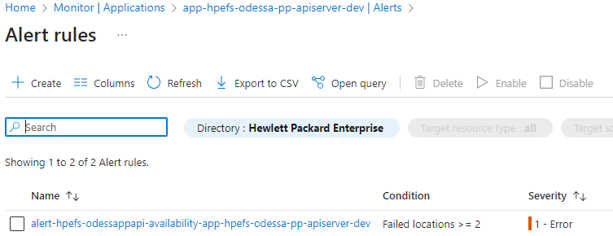

**PP Batch Jobs**

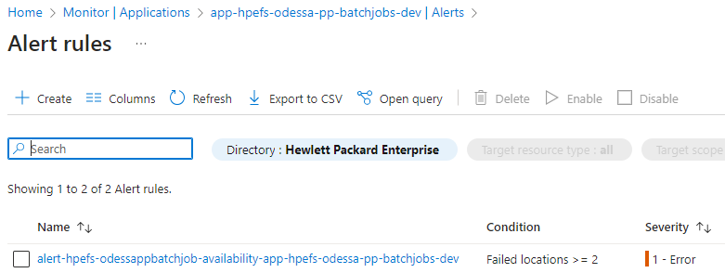

### 7.2.2 Common Action Groups



### 7.2.3 Custom Matching Conditions (CPU)



### 7.2.4 Custom Matching Conditions (Memory)



## 7.3 SQL MI Alerts

List of alerts created for the core app service.

### 7.3.1 Disk Space Shortage

* **Disk Space Shortage Query**

AzureDiagnostics

| extend spaceUsed = storage_space_used_mb_s

| extend spaceReserved = reserved_storage_mb_s

| extend storageSpacePercentage = todouble(spaceUsed) * 100 / todouble(spaceReserved)

| project TimeGenerated, storageSpacePercentage, spaceReserved, spaceUsed

| top 10 by TimeGenerated desc

**Alert**

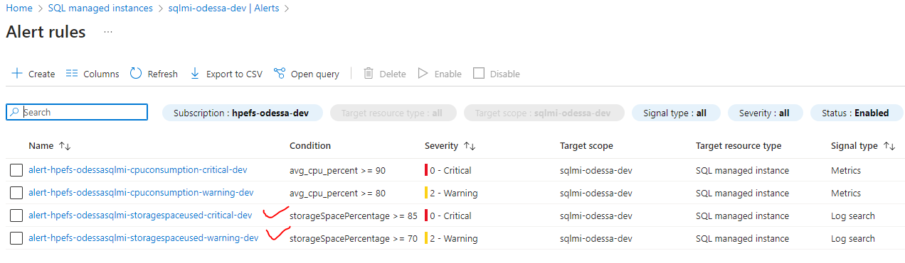

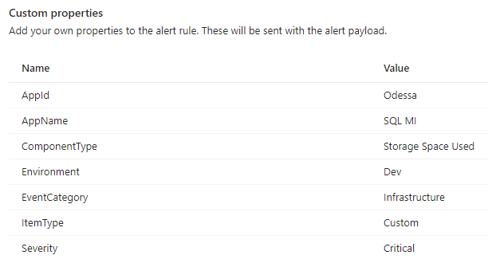

**Note:** Severity is ‘Warning’ for the Disk Space Shortage Warning Alert

### 7.3.2 CPU Consumption

**Alert**

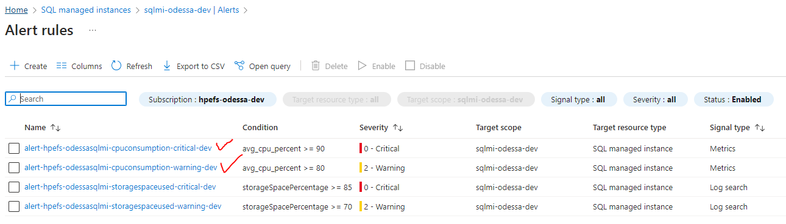

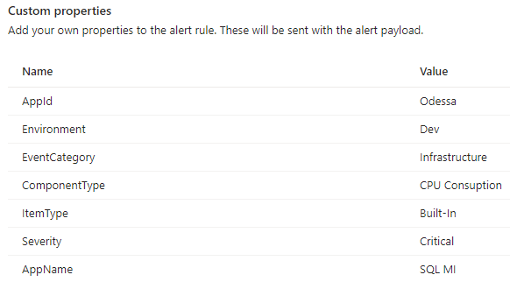

**Note:** Severity is ‘Warning’ for the CPU Consumption Warning Alert

### 7.3.3 Long Running Query

* **Long Running Query**

AzureDiagnostics   
| where ResourceProvider == "MICROSOFT.SQL"   
| where Category == 'QueryStoreRuntimeStatistics'   
| parse _ResourceId with * "/microsoft.sql/servers/" LogicalServerName "/databases/" DatabaseName   
| where duration_d/count_executions_d >=**300000000**   
|summarize executionCount = sum(count_executions_d), totalDuration = sum(duration_d) by query_hash_s   
| project query_hash_s,executionCount,totalDuration, DurationPerQueryInMin = totalDuration/executionCount/1000000/60 |order by DurationPerQueryInMin desc

Steps to create long running query alerts. The recommended duration for long running queries should be 3mins max. If any query which takes more than 5 mins should be alerted.

**300000000** (microseconds) = 5 mins.

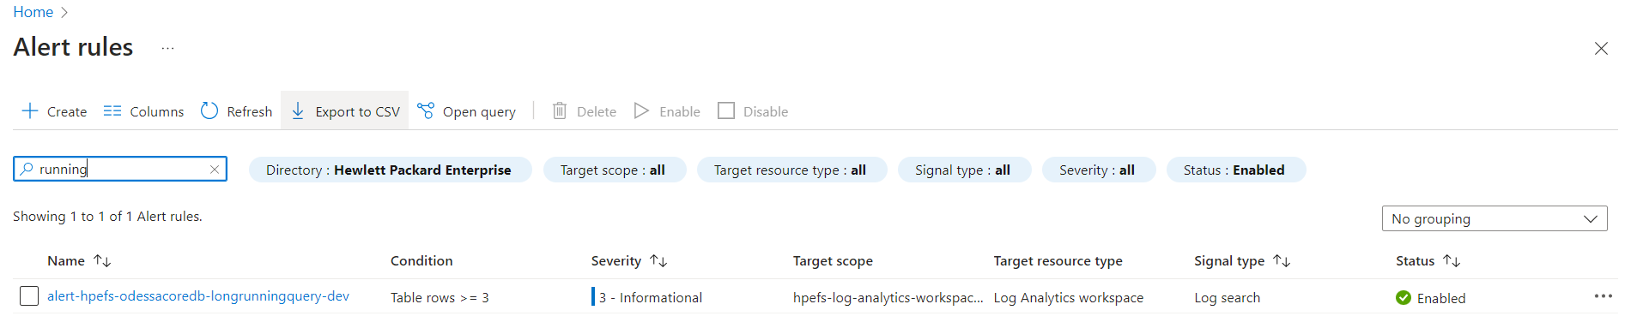

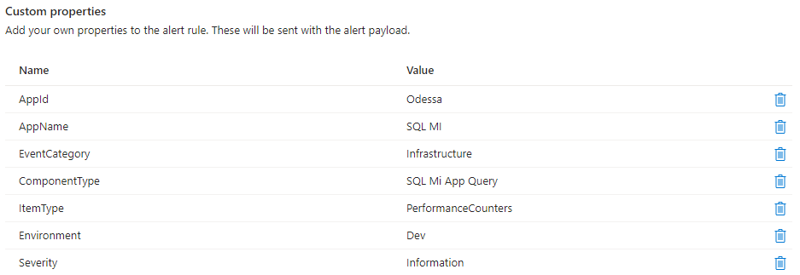

### 7.3.4 SQL MI Maintenance

**Alert**

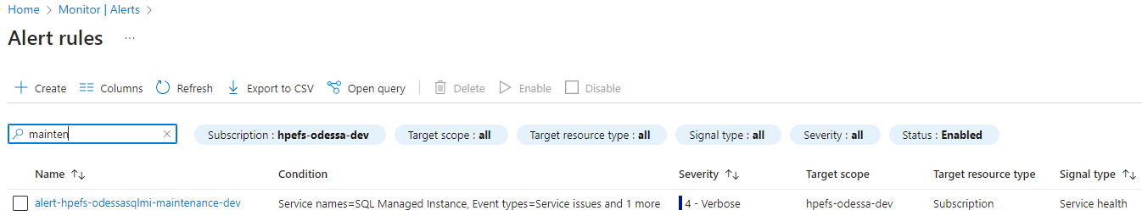

**Custom Properties**

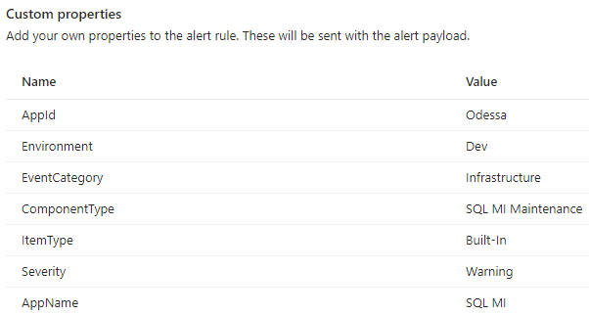

## 7.4 Storage account Alerts

List of alerts created for the core app service.

### 7.4.1 Available alerts

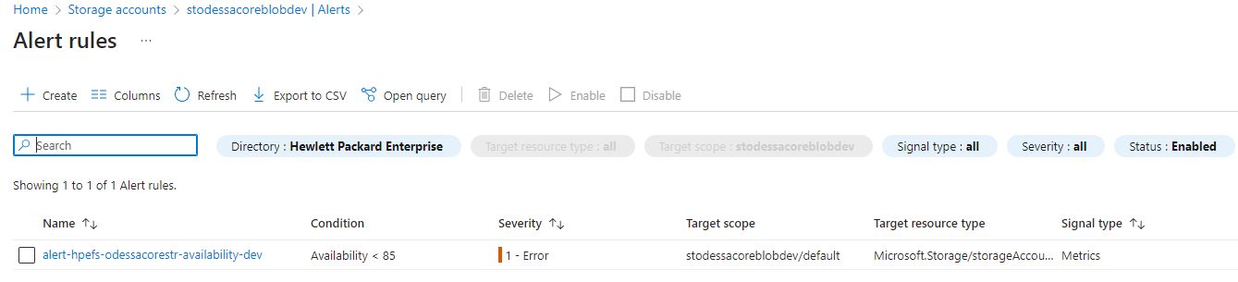

* To create alerts, go to storage account and select Metric and click on “New alert rule” menu.
* Metric – Availability
* For threshold refer existing Dev alerts.

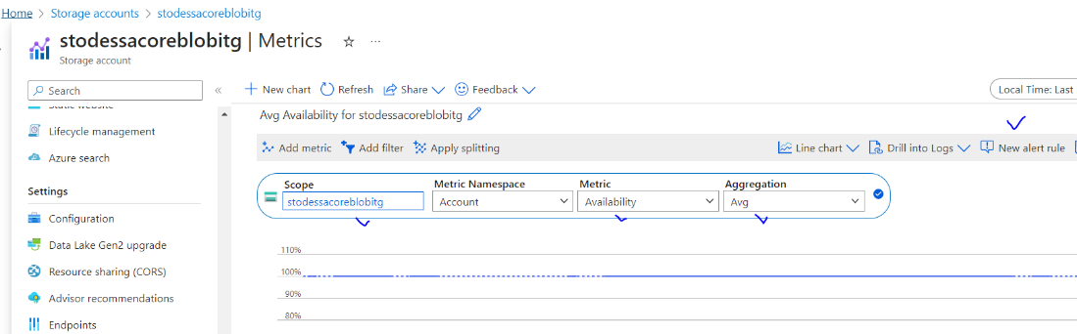

### 7.4.2 Common Action Groups

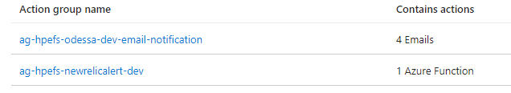

### 7.4.3 Custom Matching Conditions (Availability)

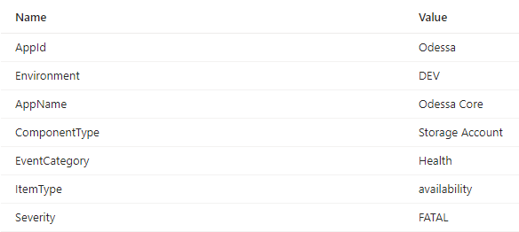

## 7.5 Key Vaults Alerts

List of the available alerts.

### 7.5.1 Available alerts

* Core Availability Key Vaults

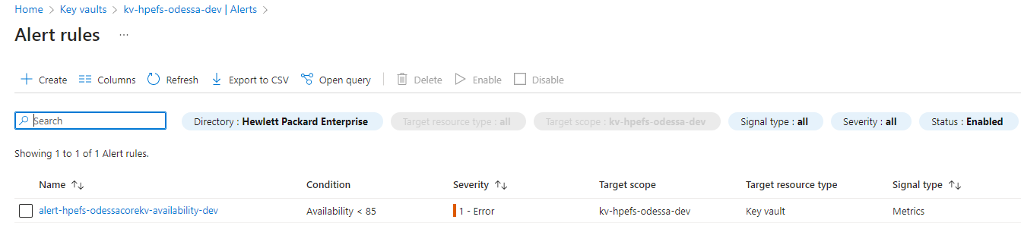

* Secret near expiry (On Hold – HPE/Mani to provide working solution)

### 7.5.2 Common Action Groups

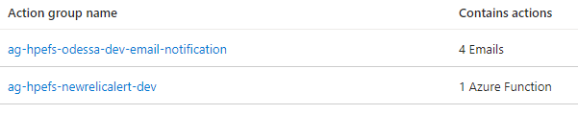

### 7.5.3 Custom Matching Conditions (Availability)

## 7.6 Data Warehouse Maintenance Alerts

* **SQL Always On Event Ids (Applicable only for STG & Prod)**
  + **Alert Name:** alert-hpefs-odessavmdmrt-sqlalwayson-stg
* **SQL Cluster Failure Management Event Ids (Applicable only for STG & Prod)**
  + **Alert Name:** alert-hpefs-odessavmdmrt-clusterfailuremanager-stg

### 7.6.1 SQL Always-On Failure Alerts

|  |  |
| --- | --- |
| **Event Description** | **Event Ids** |
| **AlwaysOn - Data Movement Suspended** | 35264 |
| **TransactionLog Unavailable** | 9001 |
| **TransactionLog Full** | 9002 |
| **DatabaseCorruptionAlert** | 823, 824, 829 |
| **AOAG Failover event** | 1480 |
| **WFC is offline** | 41049 |
| **AOAG Offline** | 41093 |
| **AOAG Connection Broken** | 35267 |
| **Backup Failure** | 3041 |
| **SQL Server Down** | 17148 |

* **Alert Name -** alert-hpefs-odessavmdmrt-sqlalwayson-stg
* **Query**

Event   
| where EventID in (35264, 9001, 9002, 823, 824, 829, 1480, 41049, 41093, 35267, 3041, 17148) and Computer startswith 'vmdatamart'

* **Alert**

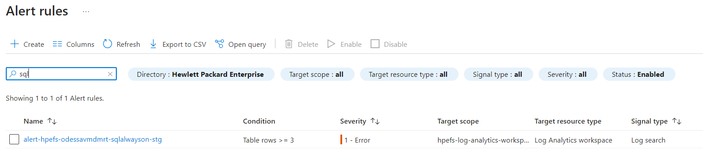

* **Custom Matching Conditions**

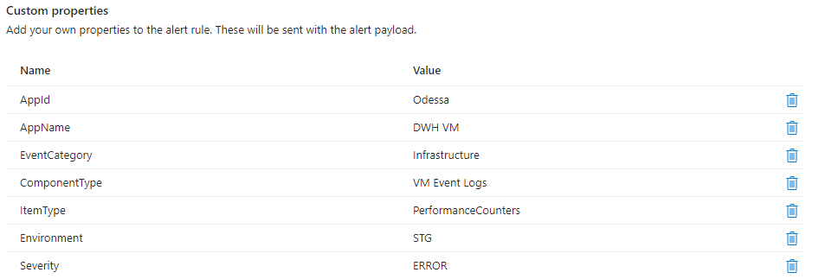

### 7.6.2 Windows Failover Cluster Monitoring Alerts

|  |  |
| --- | --- |
| **Event Description** | **Event Ids** |
| **Cluster Failover\nodes being removed from active Failover Cluster** | 1135 |
| **Clustered Service or Application Availability** | 1069 |
| **Quorum and Connectivity Needed for Quorum** | 1177 |
| **Cluster Service Startup**  **https://learn.microsoft.com/en-us/previous-versions/windows/it-pro/windows-server-2008-R2-and-2008/cc773418(v=ws.10)** | 1006 |

* **Alert Name -** alert-hpefs-odessavmdmrt-clusterfailuremanager-stg
* **Query**

Event   
| where EventID in (1135, 1069, 1177, 1006) and Computer startswith 'vmdatamart'

* **Alert**

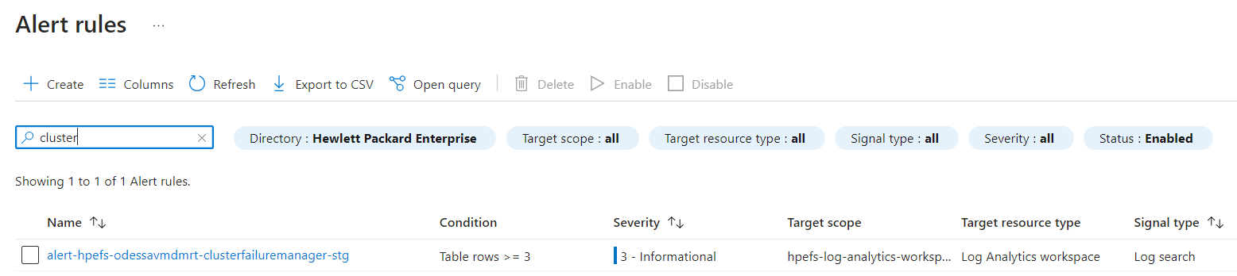

* **Custom Matching Conditions**

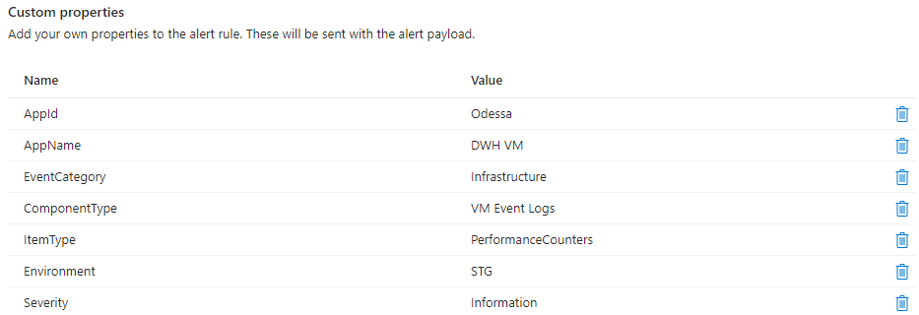

### 7.6.3 Maintenance (VM Start & Stop) Alerts

|  |  |
| --- | --- |
| **Event Description** | **Event Ids** |
| VM Restart OR Shutdown | 1074 |
| Log Service Stopped | 6006 |

* **Query**

Event

| where EventID in (1074, 6006) and Computer startswith 'vmdatamart'

* **Alert**

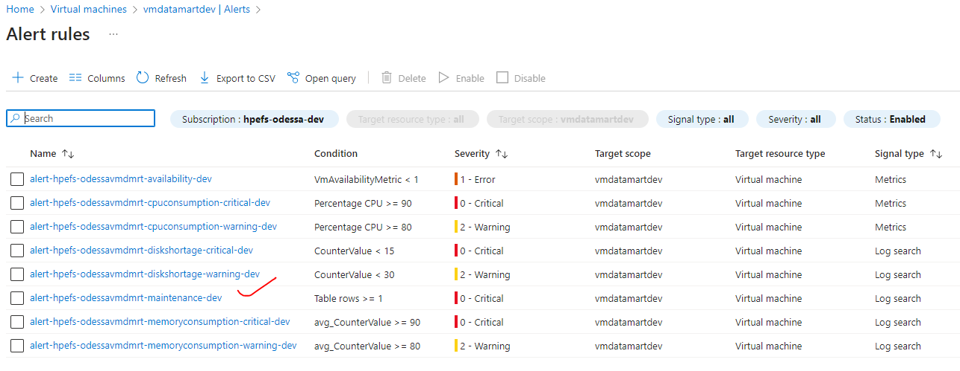

* **Custom Matching Conditions**

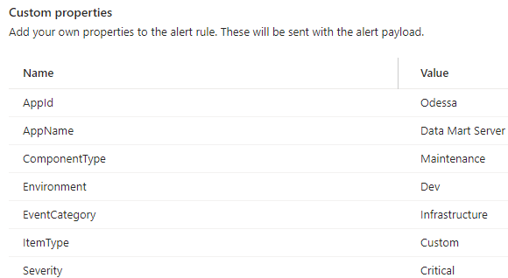

### 7.6.4 Performance Alerts

* **Memory Consumption Query –**

Perf

| where Computer startswith "vmdatamart"

| where CounterName == "% Used Memory"

| project TimeGenerated, CounterName, CounterValue

| summarize avg(CounterValue) by CounterName, bin(TimeGenerated, 5m)

| top 10 by TimeGenerated desc

* **Critical Threshold Value -**

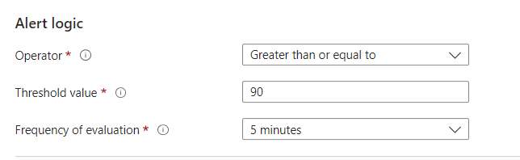

* **Warning Threshold Value -**

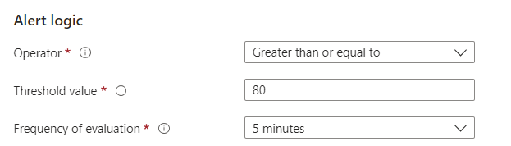

* **Alert**

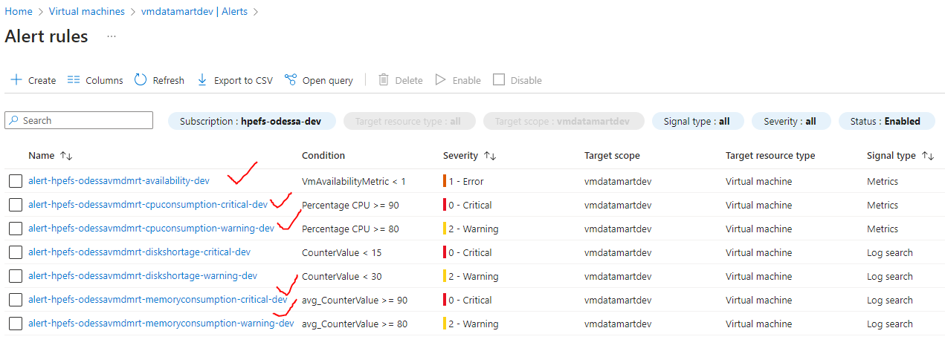

* **Custom Matching Conditions**
* Availability

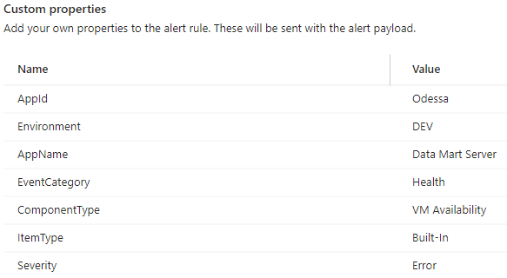

* CPU Consumption

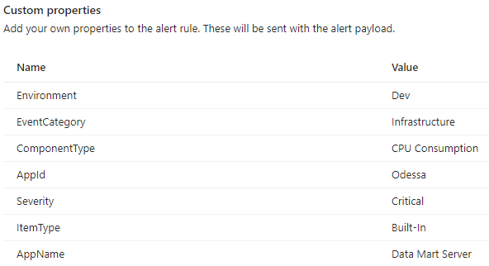

Note : Severity is ‘Warning’ for the CPU Consumption warning alert

* Memory Consumption

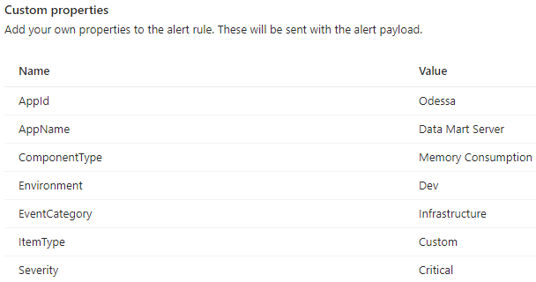

Note : Severity is ‘Warning’ for the Memory Consumption alert.

### 7.6.5 Disk Shortage Space Alerts

* **Query**

Perf

| where Computer startswith " vmdatamart"

| where ObjectName == "LogicalDisk"

| where CounterName == "% Free Space"

| top 10 by TimeGenerated desc

Note: If % Free space is less than 15 % (100 – 85 %) then an alert will be fired.

* **Alert**

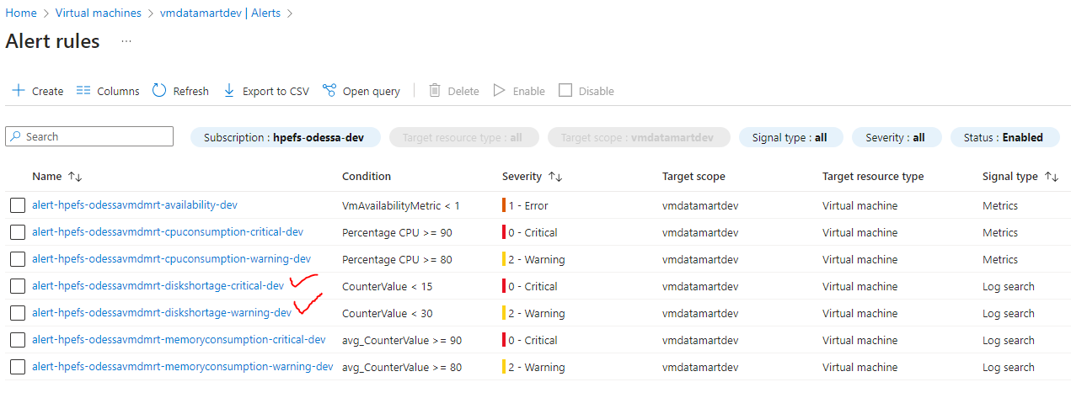

* **Custom Matching Conditions**

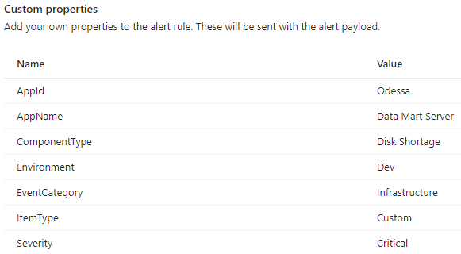

**Note:** Severity is ‘Warning’ for the Disk Shortage warning alert.

### 7.6.6 SQL On VM Backup Failure Alerts

**Query**

AddonAzureBackupJobs  
| where BackupManagementType == 'IaaSVM' and JobStatus == 'Failed'  
| project TimeGenerated, OperationName, Category, BackupManagementType, JobFailureCode, JobOperation   
| top 10 by TimeGenerated desc

**Alert**

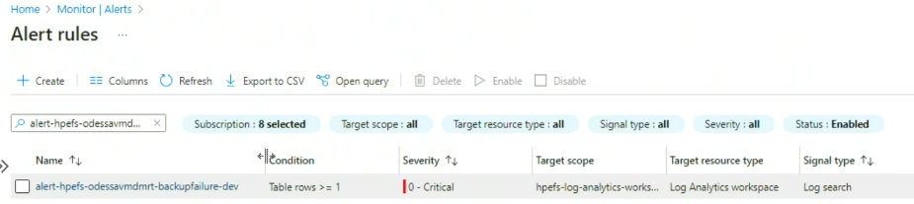

## 7.7 Report Server VM Alerts

### 7.7.1 Maintenance Alerts

|  |  |
| --- | --- |
| **Event Description** | **Event Ids** |
| VM Restart OR Shutdown | 1074 |
| Log Service Stopped | 6006 |

* **Alert Name:** alert-hpefs-odessavmrpt-maintenance-dev
* **Query**

Event

| where EventID in (1074, 6006) and Computer startswith 'vmreportsvr'

* **Alert**

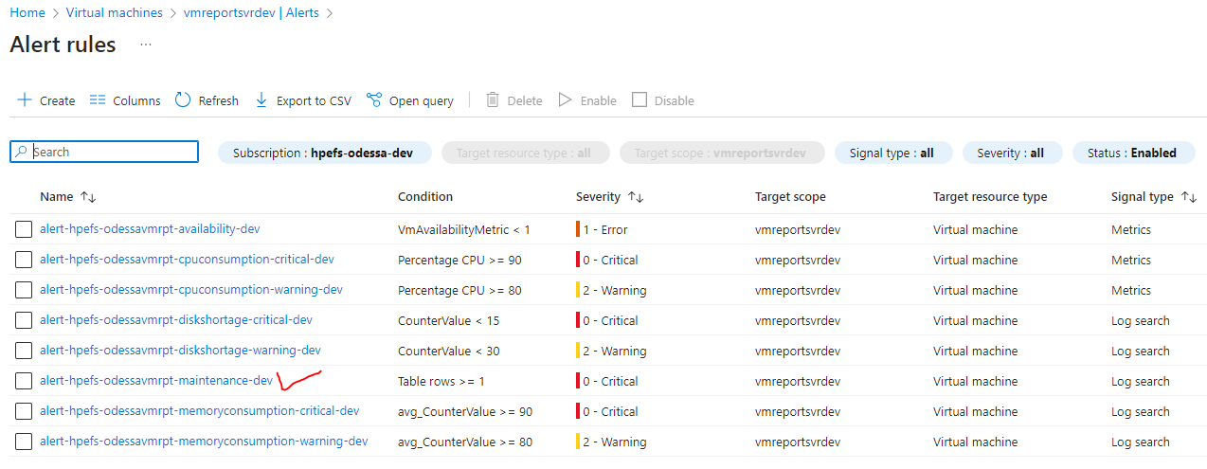

* Custom Matching Conditions

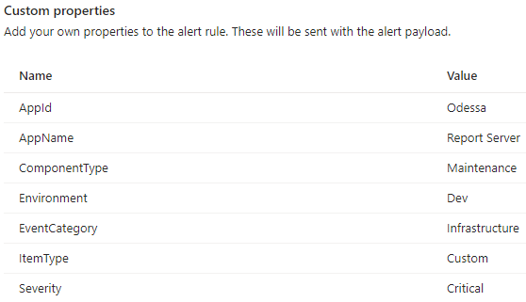

### 7.7.2 Performance Alerts

* **Memory Consumption Query**

Perf

| where Computer startswith "vmreportsvr"

| where CounterName == "% Used Memory"

| project TimeGenerated, CounterName, CounterValue

| summarize avg(CounterValue) by CounterName, bin(TimeGenerated, 5m)

| top 10 by TimeGenerated desc

* **Alerts**

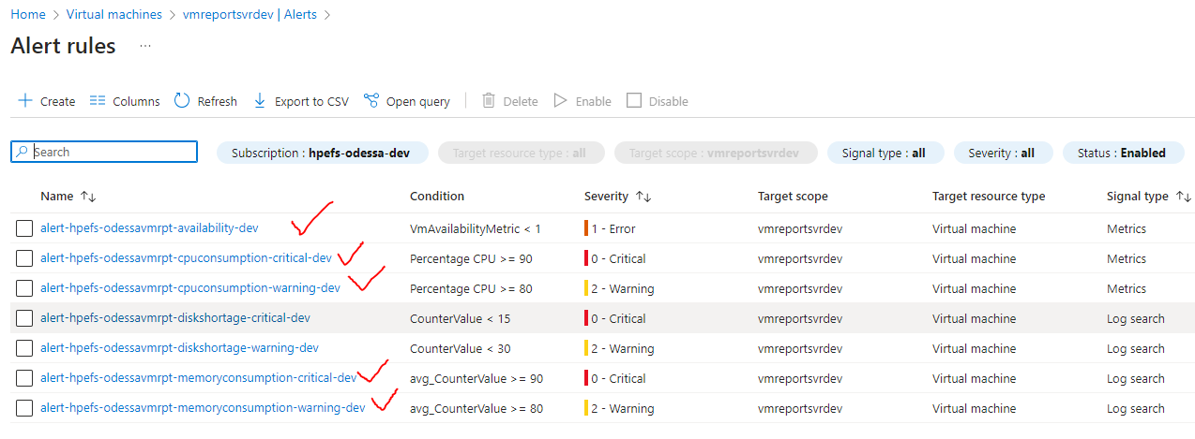

* Custom Matching Conditions
* Availability

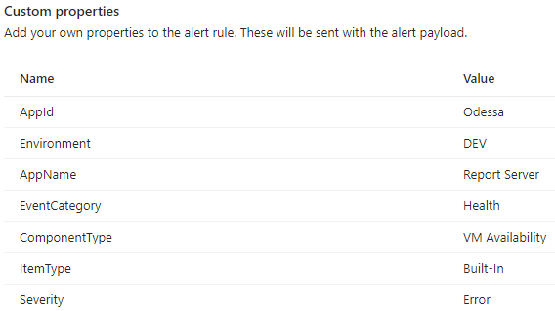

* CPU Consumption

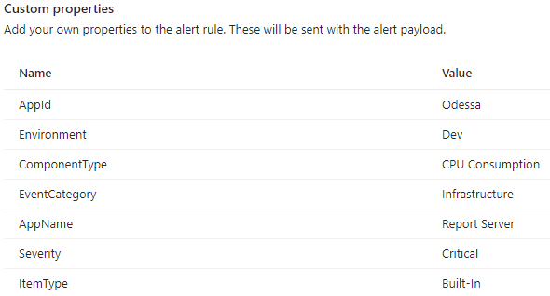

Note : Severity is ‘Warning’ for the CPU Consumption warning alert.

* Memory Consumption

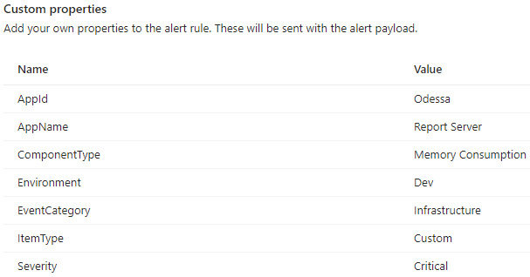

Note : Severity is ‘Warning’ for the Memory Consumption warning alert.

### 7.7.3 Disk Shortage Space Alerts

* **Query**

Perf

| where Computer startswith "vmreportsvr"

| where ObjectName == "LogicalDisk"

| where CounterName == "% Free Space"

| top 10 by TimeGenerated desc

* **Alerts**

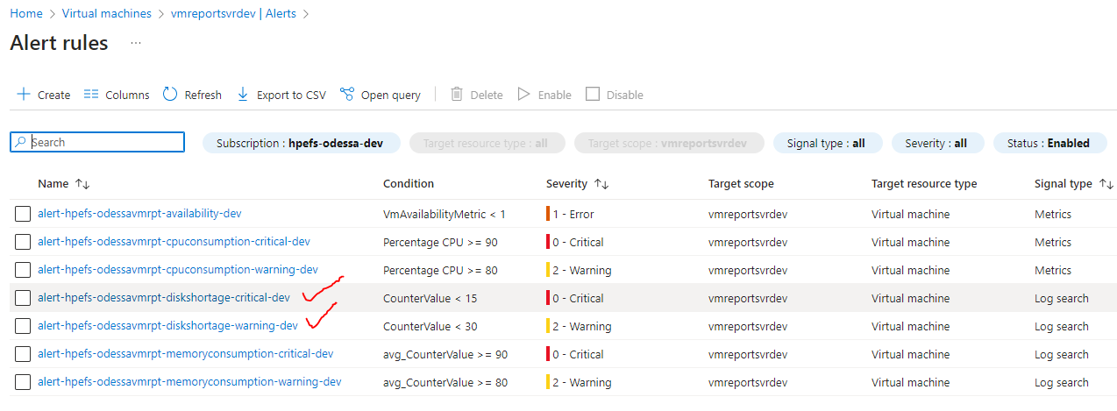

* Custom Matching Conditions

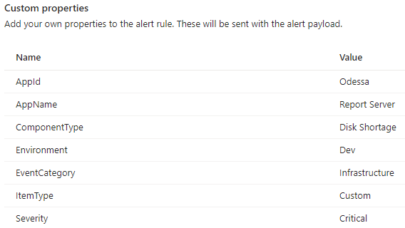

Note : Severity is ‘Warning’ for the Disk Shortage warning alert.

### 7.7.4 VM IIS Service

**IIS Service Stopped Event Id**

|  |  |
| --- | --- |
| **Event Description** | **Event Ids** |
| IIS Stopped | 7036 |

* **Name**: alert-hpefs-odessavmrpt-iisservice-dev
* **Query**

Event

| where EventID == 7036 and Computer startswith 'vmreportsvr'

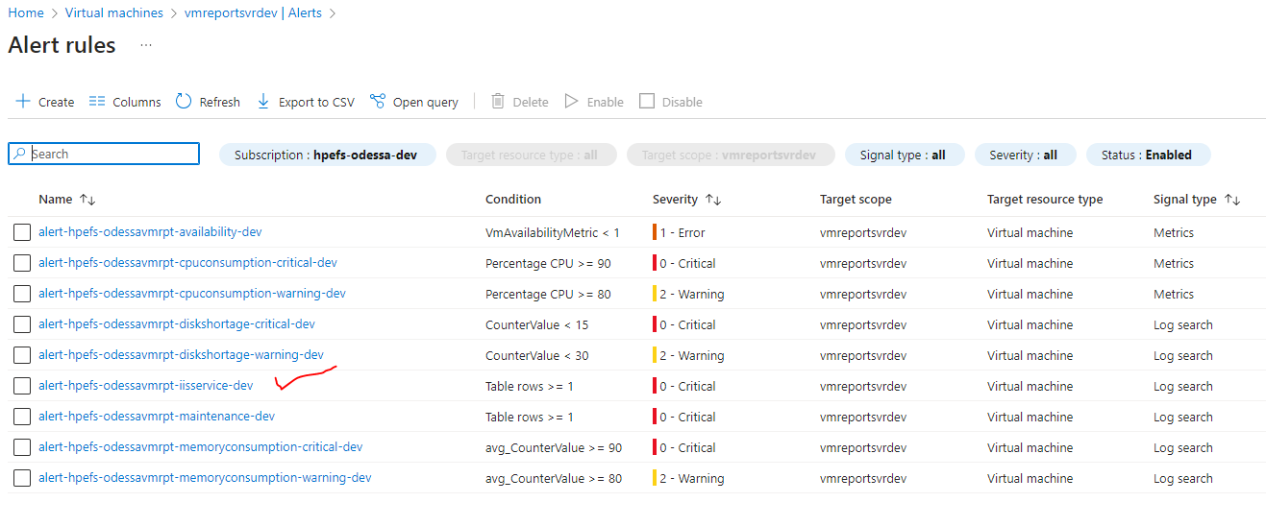

* Custom Matching Conditions

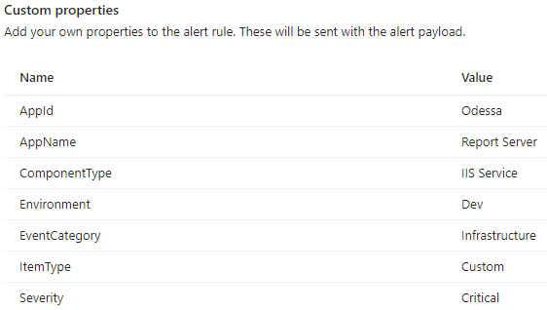

# 8. Configure Metrics

Navigate to Azure App service plan, select “Metrics” under “Monitoring” section, user can choose various metrics parameter, Pin to Dashboard, and create alerts as well.

## 8.1 App Service Plans

App service plans for available environments environment

### 8.1.1 app-svc-plan-odessa-dev

Matrix configuration for ‘app-srv-plan-odessa-dev’ app service plan as below.

#### 8.1.1.1 CPU Percentage.

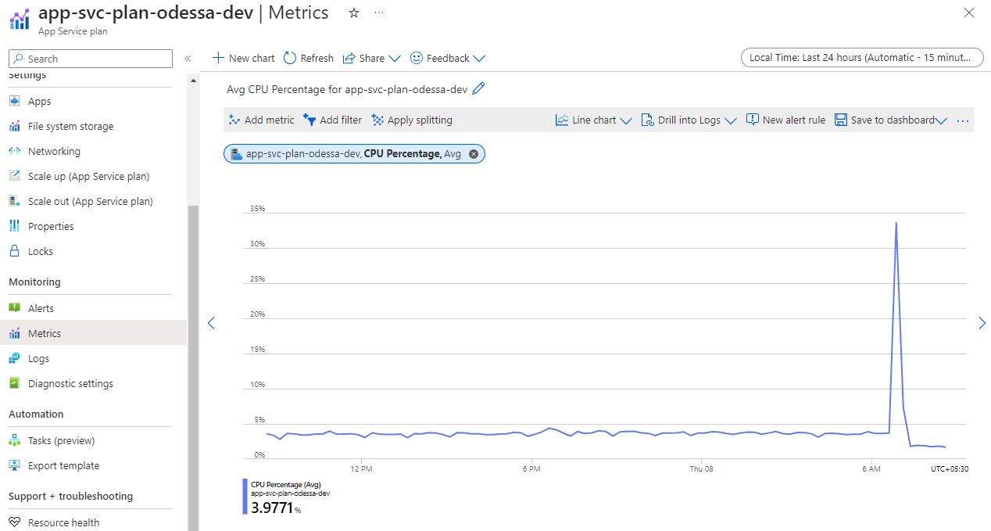

#### 8.1.1.2 Memory Percentage.

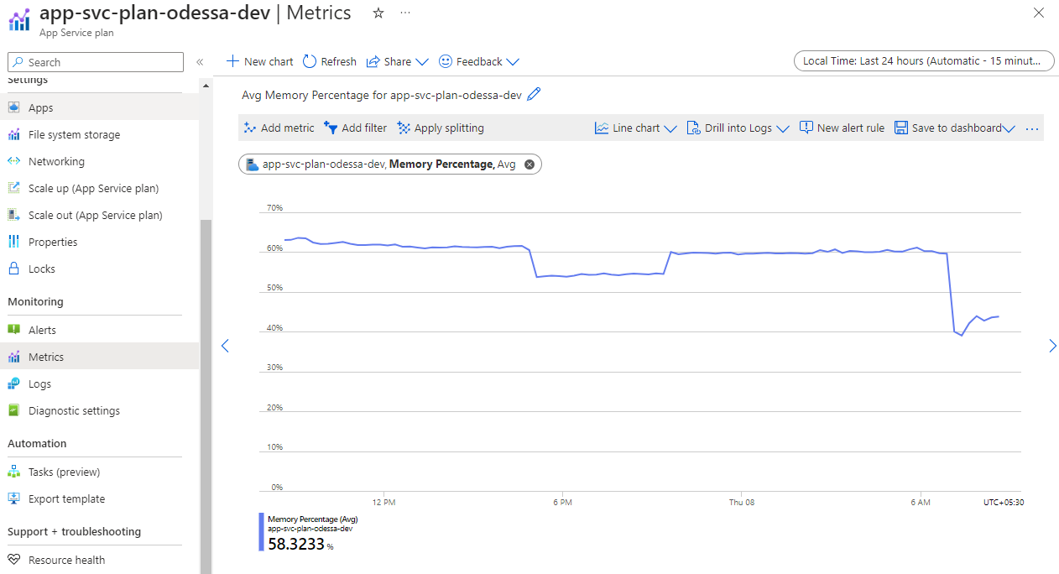

#### 8.1.1.3 Data In

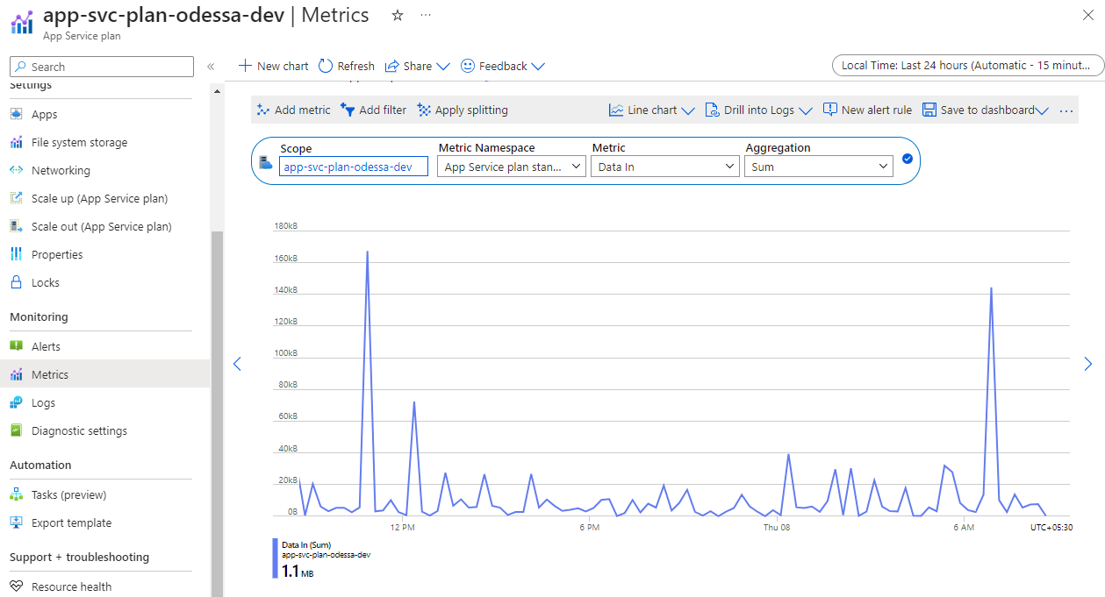

#### 8.1.1.4 Data Out

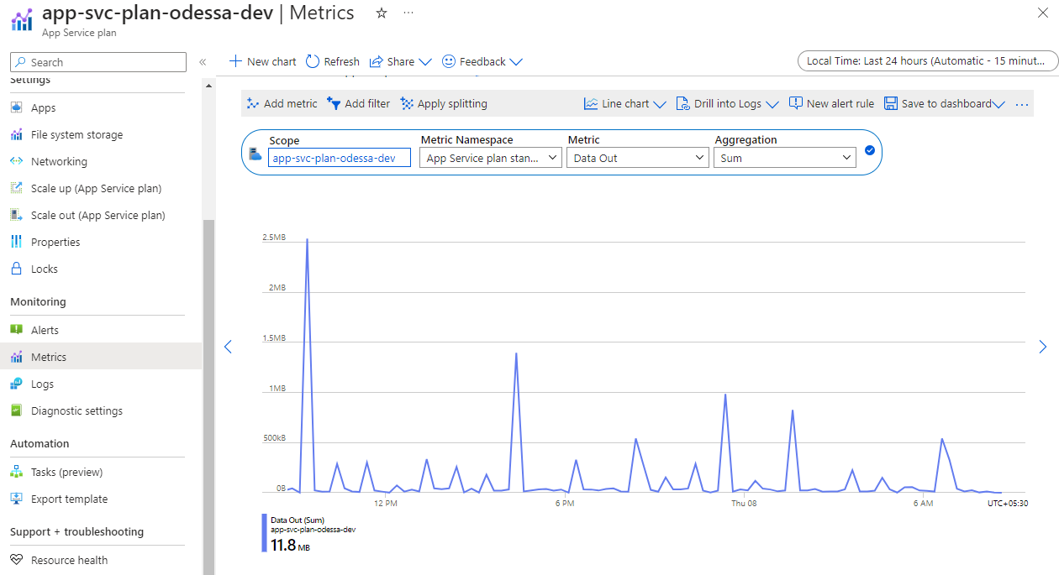

### 8.1.2 app-svc-plan-odessa-pp-dev

Matrix configuration for ‘app-srv-plan-odessa-pp-dev’ app service plan as below.

#### 8.1.2.1 CPU Percentage.



#### 8.1.2.2 Memory Percentage.



#### 8.1.2.3 Data In



#### 8.1.2.4 Data Out



## 8.2 SQL Managed Instance Metrics

* Navigate to SQL MI, select “Metrics” under “Monitoring” section, user can choose various metrics parameter, Pin to Dashboard, and create alerts as well.

### 8.2.1 Avg CPU Percentage.

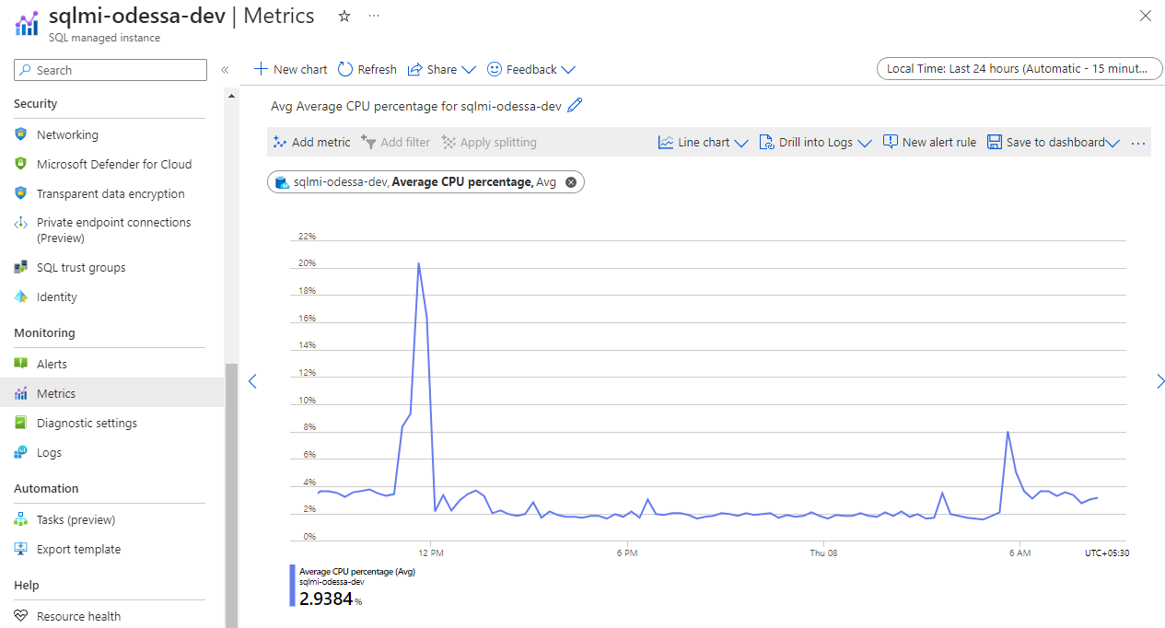

### 8.2.2 Storage space used.

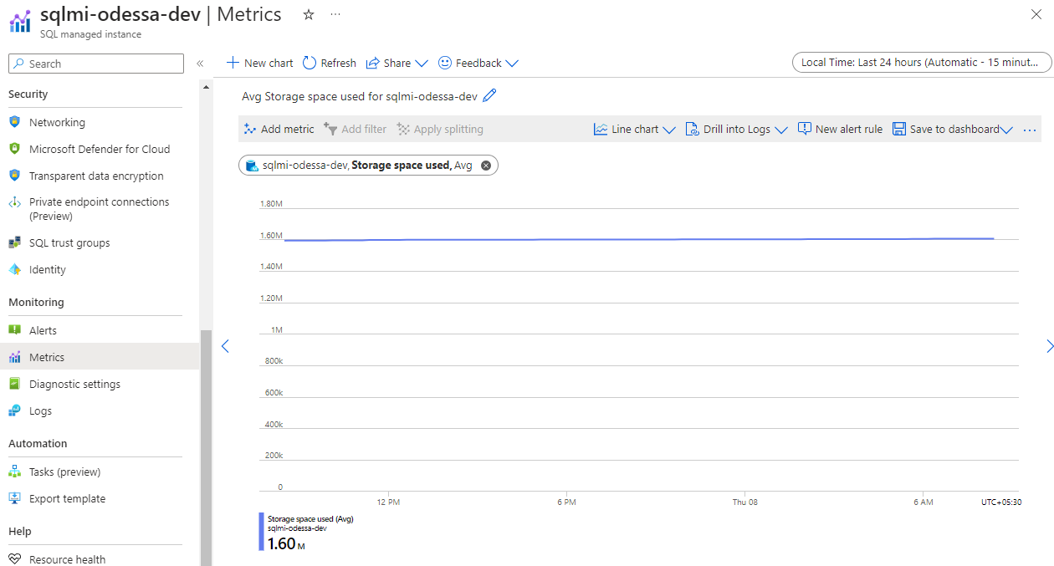

# 9. Configure Dashboard

We can categories dashboard into three major types, such as Infrastructure, Performance, and Logs (Which is derived from Metrics, Availability, and Insights).

Please find the below list which will help to identify the various components and pin it to different dashboards. Users can refer to STG dashboard for easy understanding.

## 9.1 Infrastructure Dashboard

**Core & Shared** (Report Builder, DWH & Report Server)

Note: Refer Section 9.1.1 for the below resource’s metrics

|  |  |  |  |
| --- | --- | --- | --- |
| **S No.** | **Application** | **Resources** | **Metrics/Queries** |
| 1 | Core | App services (App) | CPU, Memory, Availability |
| 2 | Core | App services (API) | CPU, Memory, Availability |
| 3 | Core | App services (Job) | CPU, Memory, Availability |
| 4 | Shared | SQL MI | CPU, Storage available vs Used. |
| 5 | Core & Reportbuilder | Storage accounts | Blob Capacity, Blob Count, Availability |
| 6 | Shared | Report Server, Data Warehouse | CPU, Network In, Network Out, Disk Read, Disk Write, Available Memory Bytes |
| 7 | Core & Reportbuilder | Key vault | Availability |
| 8 | Core | App services (App) | Application Map |
| 9 | Core | App services (API) | Application Map |

**Partner Portal**

Note: Refer Section 9.1.2 for the below resource’s metrics

|  |  |  |
| --- | --- | --- |
| **S No.** | **Resources** | **Metrics/Queries** |
| 1 | App Service | CPU, Memory, Availability |
| 2 | API Service | CPU, Memory, Availability |
| 3 | Job Service | CPU, Memory, Availability |
| 4 | Storage Accounts | Blob Capacity, Blob Count, Availability |
| 5 | Key Vaults | Availability |
| 6 | App services (App) | Application Map |
| 7 | App services (Api) | Application Map |

**Report Builder**

Note: Refer Section 9.1.3 for the below resource’s metrics

|  |  |  |
| --- | --- | --- |
| **S No.** | **Resources** | **Metrics/Queries** |
| 1 | App Service | CPU, Memory, Availability |
| 2 | Job Service | CPU, Memory, Availability |
| 3 | App services (App) | Application Map |

### 9.1.1 Core & Shared (Report Builder, DWH & Report Server)

a. App service flow

* App Service Availability
* App Service CPU Percentage
* App Service Memory Percentage

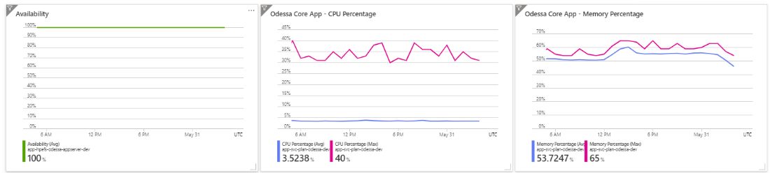

1. Api service flow

* Api Service Availability
* Api Service CPU Percentage
* Api Service Memory Percentage

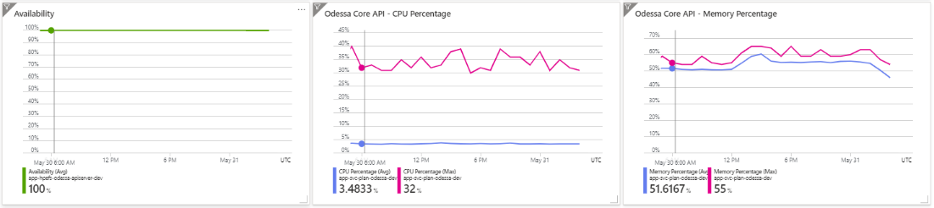

1. Job service flow

* Job Service Availability
* Job Service CPU Percentage
* Job Service Memory Percentage

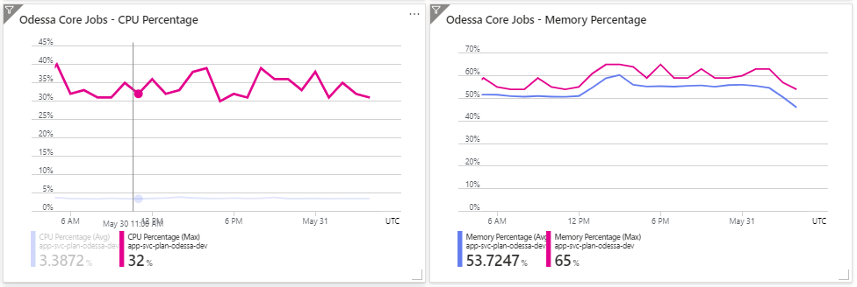

1. SQL MI

* CPU Percentage
* Space reserved vs used

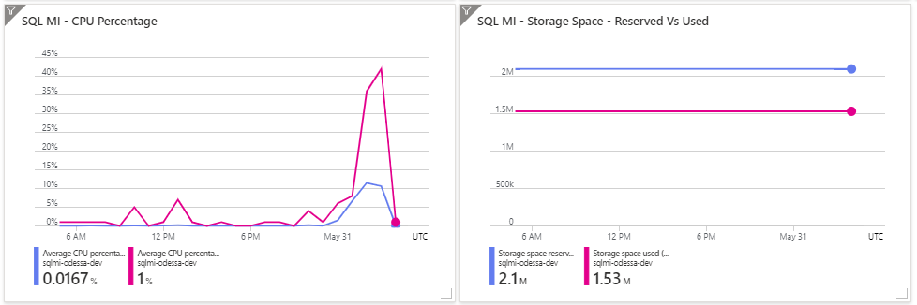

1. Storage Account

* Storage Blob Availability
* Storage Blob Capacity Usage
* Storage Blob Count

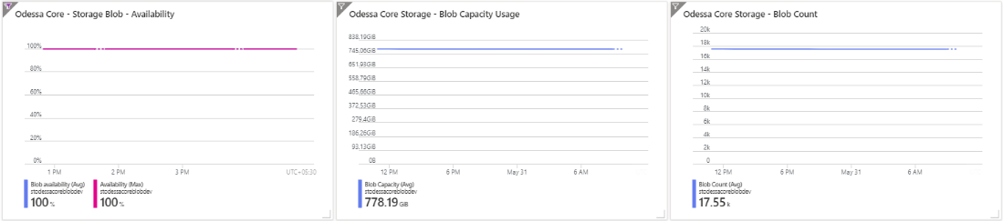

1. Report Server & DWH VM

* Availability
* CPU Usage
* Available Memory Bytes
* Disk Read Bytes
* Disk Write Byte
* Network In
* Network Out

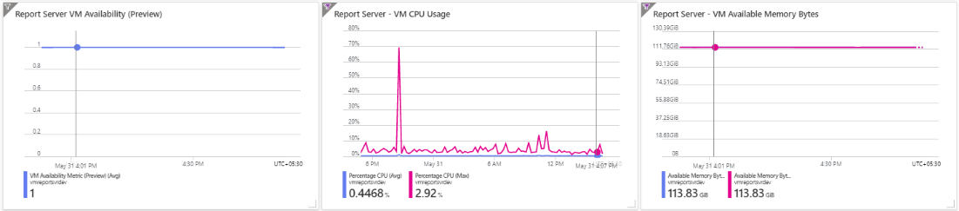

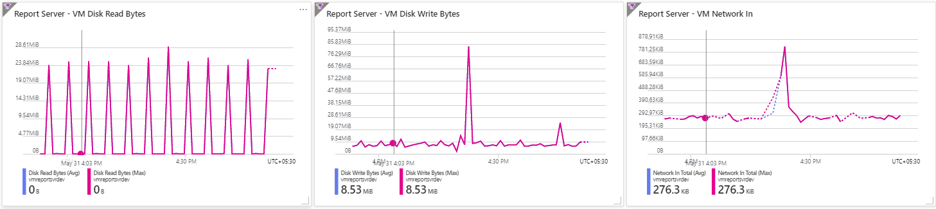

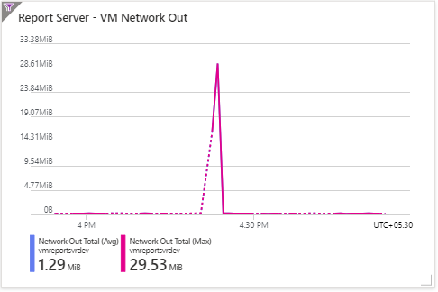

j. Key Vaults

* Availability

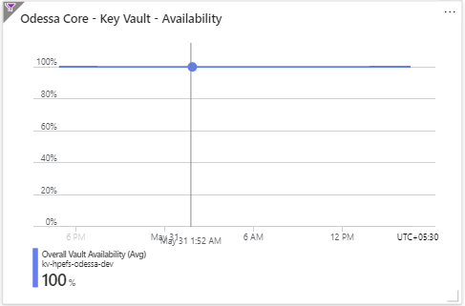

k. App server application map

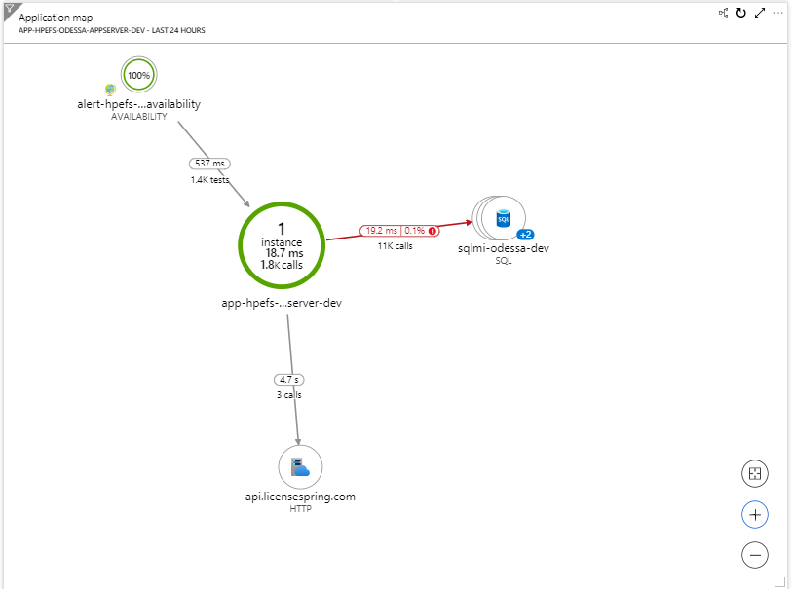

1. Api server application map

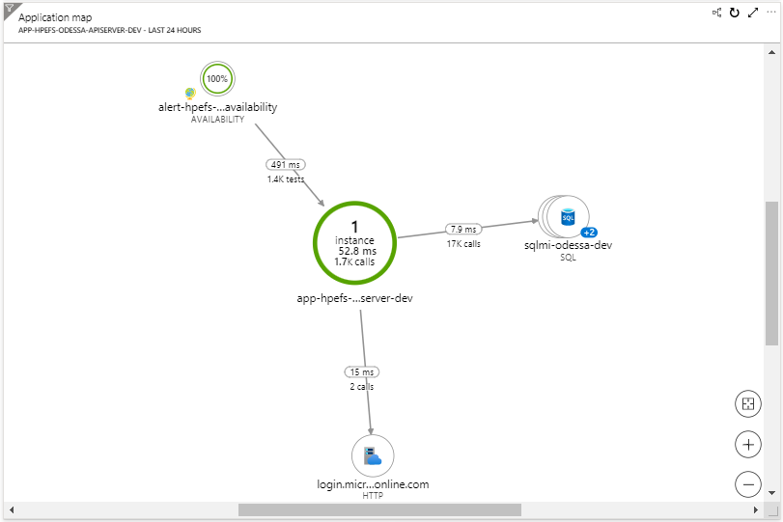

### 9.1.2 Partner Portal

a. App service flow

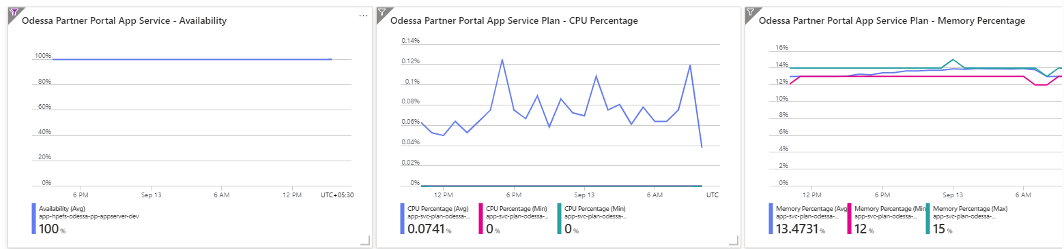

b. Api service flow

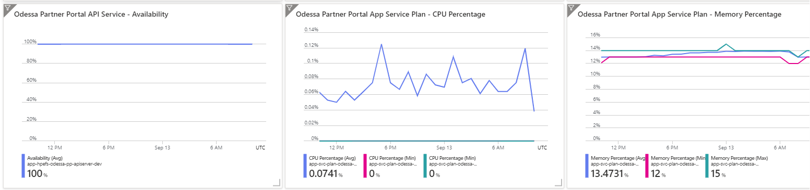

c. Job service flow

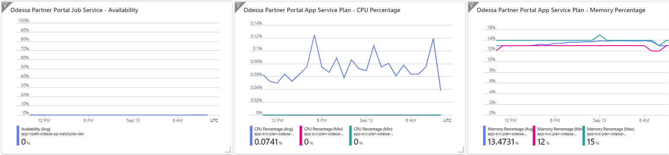

d. Storage account

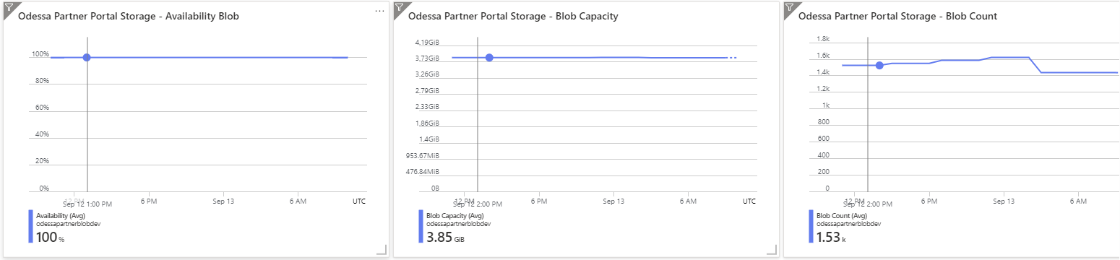

e. Key vault

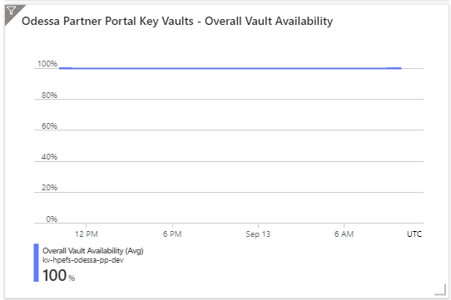

1. App & API service MAP

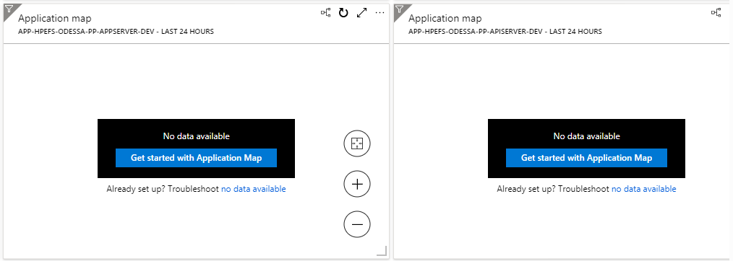

### 9.1.3 Report Builder

a. App service flow

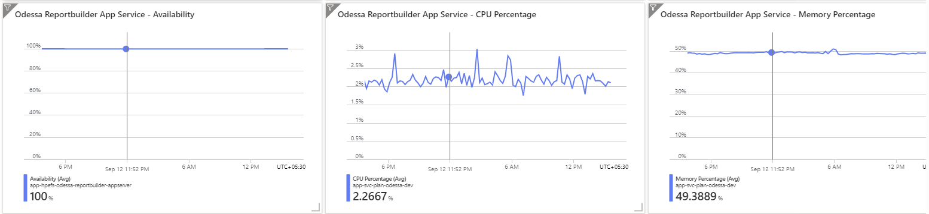

b. Api service flow

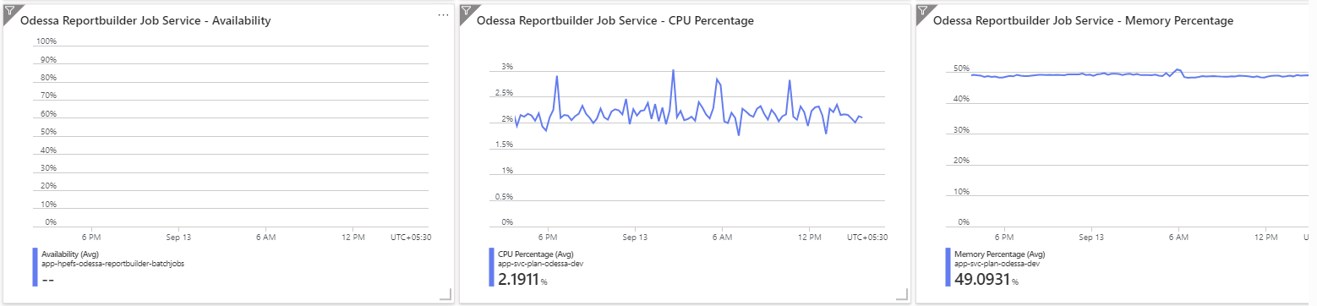

c. App service map

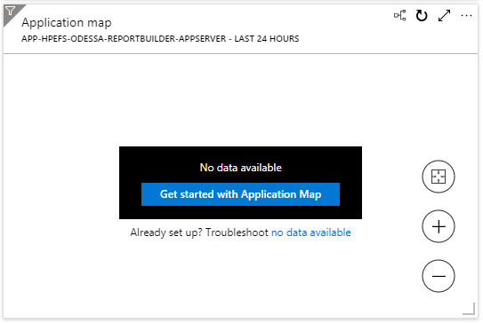

## 9.2 Performance Dashboard

Core & Shared (Report Builder, Report Server, DWH)

Note: Refer Section 9.2.1 for the below resource’s metrics

|  |  |  |  |
| --- | --- | --- | --- |
| **S No.** | **Application** | **Resources** | **Metrics/Queries** |
| 1 | Core | App services (App) | Requests, Response Time, Data In, Data out, Operation performance, Dependency performance. |
| 2 | Core | App services (API) | Requests, Response Time, Data In, Data out, Operation performance, Dependency performance. |
| 3 | Core | App services (Job) | Requests, Response Time, Data In, Data out |
| 4 | Core, Partner Portal, Reportbuilder | SQL MI | IO Requests |
| 5 | Core, Reportbuilder | Storage accounts | Ingress, Egress |
| 6 | Core, Reportbuilder | Key vault | Latency, API Hits, API Results |
| 7 | Core | App configuration | HTTP Incoming Request Count, HTTP Incoming Request Duration |

**Partner Portal**

Note: Refer Section 9.2.2 for the below resource’s metrics

|  |  |  |  |
| --- | --- | --- | --- |
| **S No.** | **Application** | **Resources** | **Metrics/Queries** |
| 1 | Partner Portal | App Service | Requests, Response Time, Data In, Data out, Operation performance, Dependency performance. |
| 2 | Partner Portal | API Service | Requests, Response Time, Data In, Data out, Operation performance, Dependency performance. |
| 3 | Partner Portal | Job Service | Requests, Response Time, Data In, Data out, Operation performance, Dependency performance. |
| 4 | Partner Portal | Storage Account | Ingress, Egress |
| 5 | Partner Portal | Key Vault | Latency, API Hits, API Results |
| 6 | Partner Portal | App Configuration | HTTP Incoming Request Count, HTTP Incoming Request Duration |

**Report Builder**

Note: Refer Section 9.2.3 for the below resource’s metrics

|  |  |  |  |
| --- | --- | --- | --- |
| **S No.** | **Application** | **Resources** | **Metrics/Queries** |
| 1 | Reportbuilder | App Service | Requests, Response Time, Data In, Data out, Operation performance, Dependency performance. |
| 2 | Reportbuilder | Job Service | Requests, Response Time, Data In, Data out, Operation performance, Dependency performance. |
|  |  |  |  |

### 9.2.1 Core & Shared (Report Builder, DWH & Report Server)

1. App service flow

* App service request
* App service response
* App Service Data In
* App Service Data Out

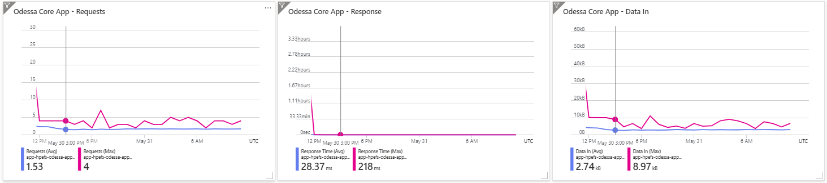

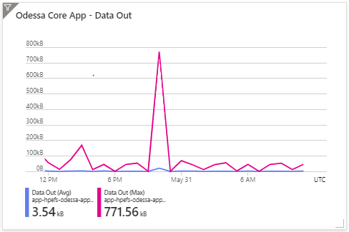

1. Api service

* Api service request
* Api service response
* Api Service Data In
* Api Service Data Out

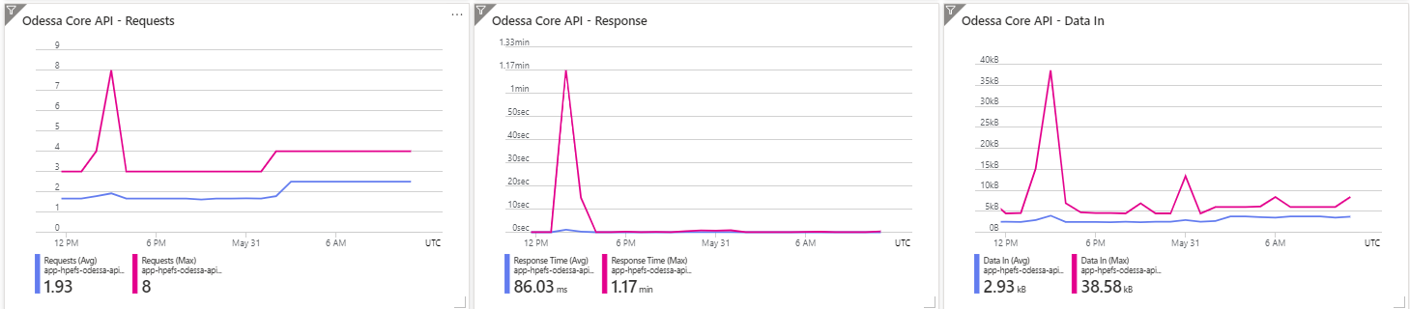

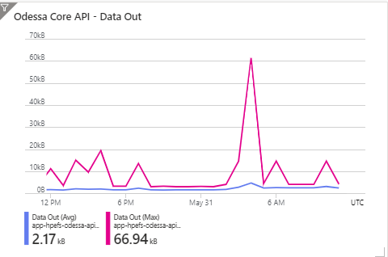

1. Job Service

* Job Service Data In
* Job Service Data Out

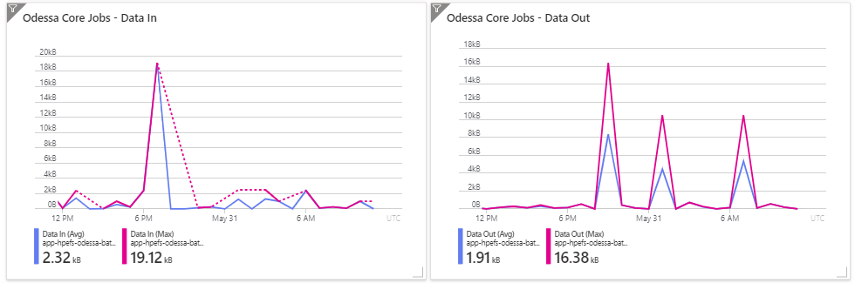

1. SQL MI

* IO Request

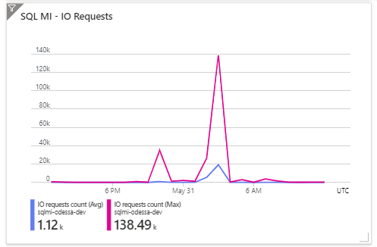

1. Storage Blob

* Storage Ingress
* Storage Egress

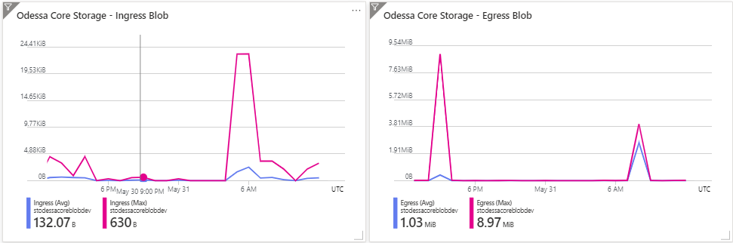

1. Key Vaults

* Key Vault Latency
* Key Vaults API Hits
* Key Vaults API Results

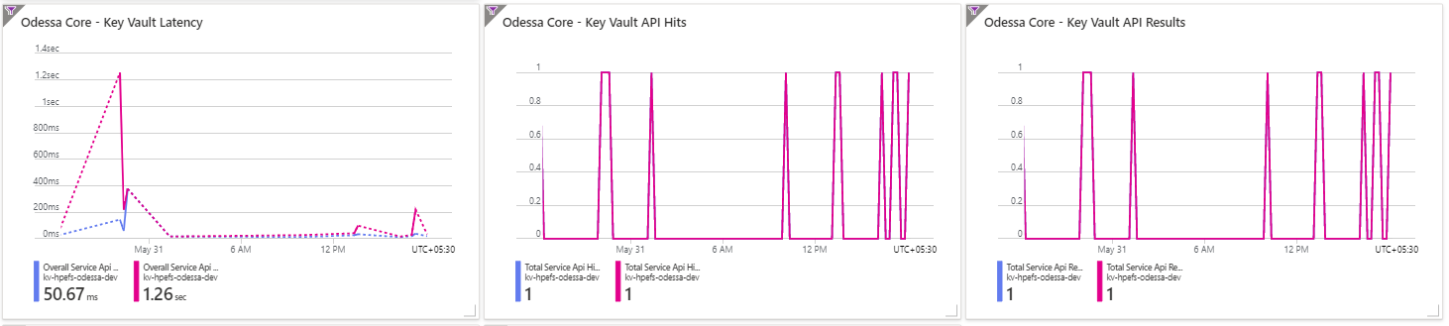

1. App Configuration

* Incoming request count
* Incoming request duration

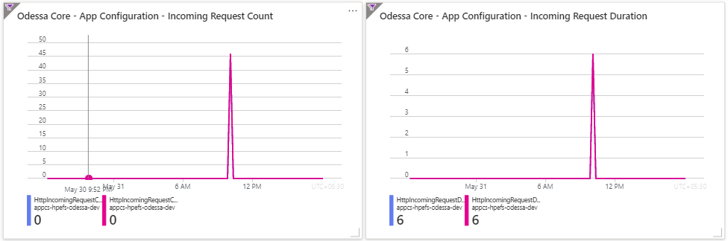

### 9.2.2 Partner Portal

a. App service flow

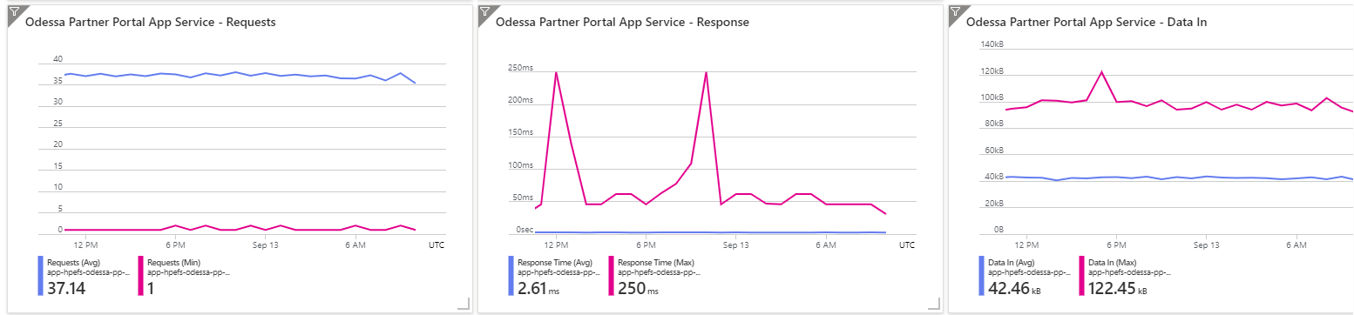

b. Api service flow

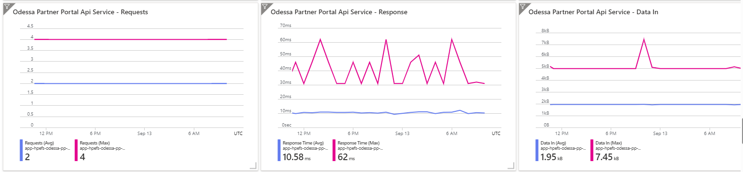

c. Job service flow

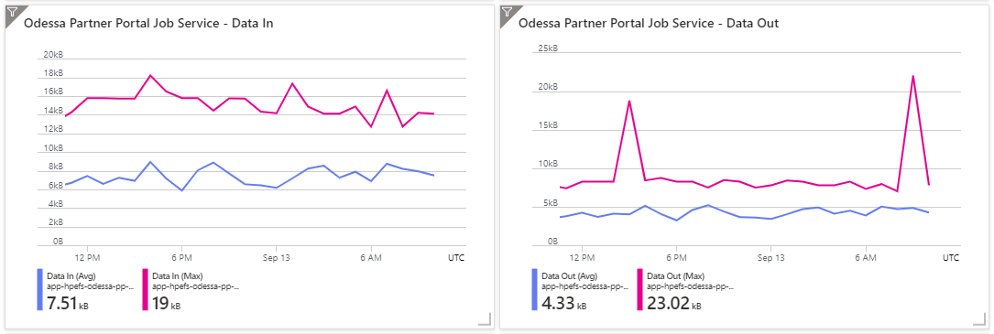

d. Storage account flow

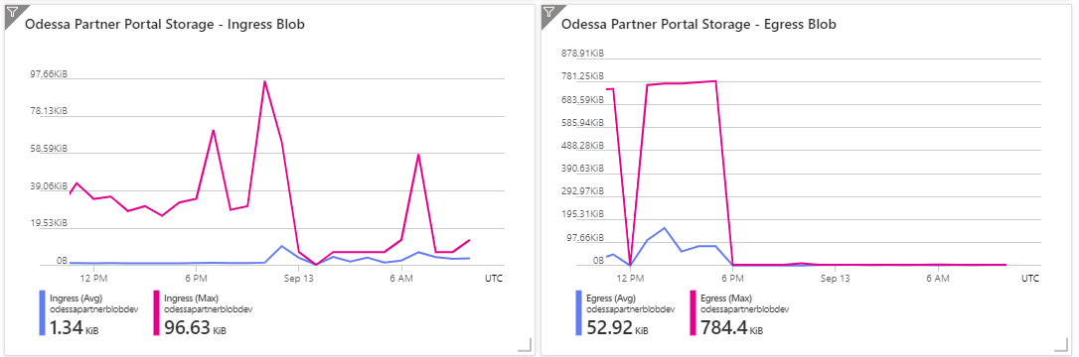

e. Key vault

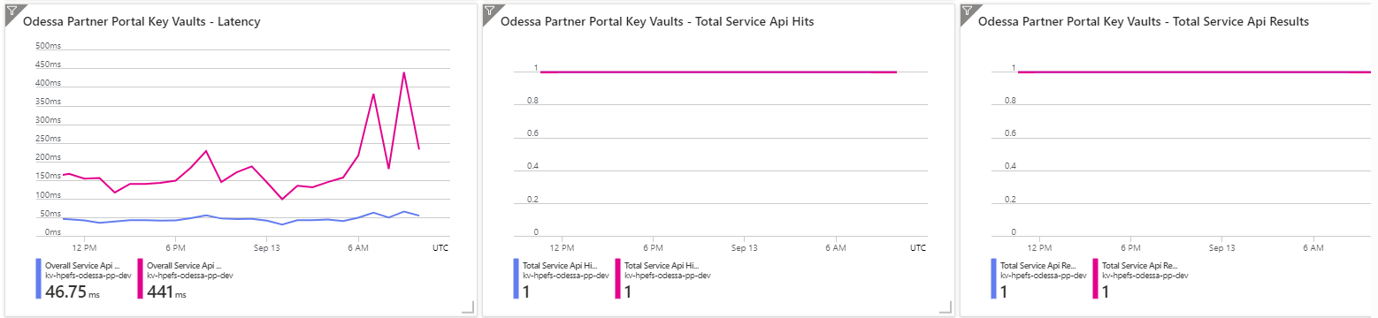

f. App configuration

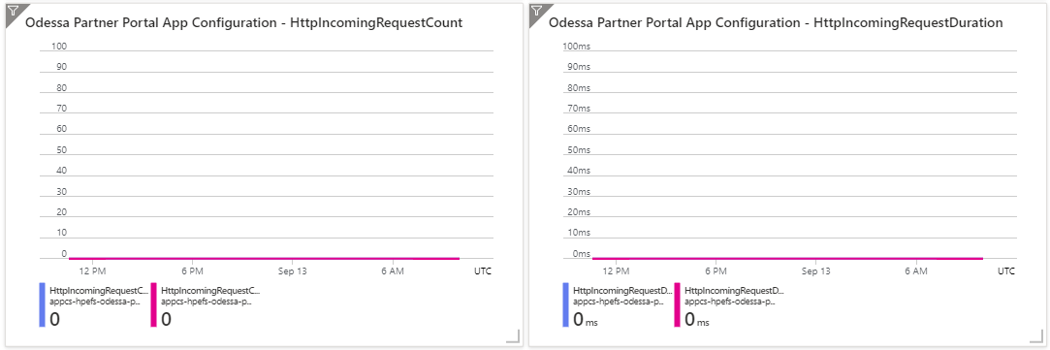

### 9.2.3 Report Builder

a. App service flow

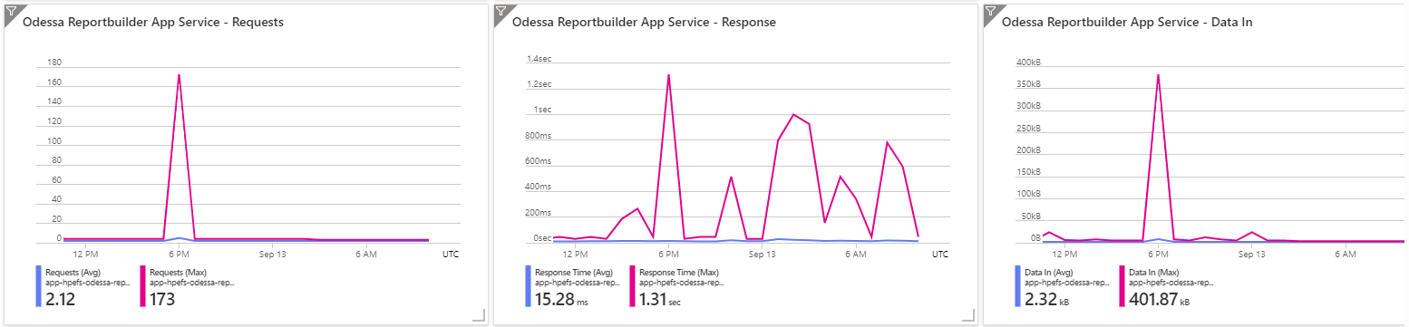

b. Job service flow

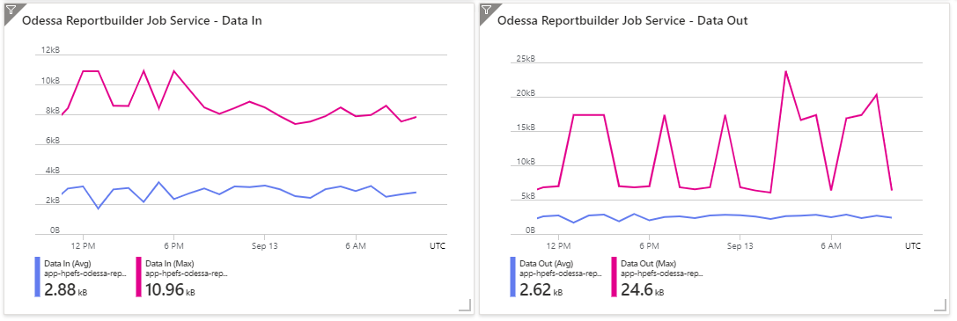

## 9.3 Logs Dashboard

**Core**

Note: Refer Section 9.3.1 for the below resource’s metrics

|  |  |  |  |
| --- | --- | --- | --- |
| **S No.** | **Application** | **Resources** | **Metrics/Queries** |
| 1 | Core | App services (App) | Operation Failures, Exception Failures, Dependency Failures, Top 10 exception types, Exceptions |
| 2 | Core | App services (API) | Operation Failures, Exception Failures, Dependency Failures, Top 10 exception types, Exceptions |
| 3 | Core | App services (Job) | Exception Failures, Top 10 exception types, Exceptions |
| 4 | Core | Custom Logs | InboundAPI_CL, OutboundAPI_CL, JobInstance_CL, BackgroundEvent_CL, InboundMessage_CL, OutboundMessage_CL |

**Partner Portal**

Note: Refer Section 9.3.2 for the below resource’s metrics

|  |  |  |  |
| --- | --- | --- | --- |
| **S No.** | **Application** | **Resources** | **Metrics/Queries** |
| 5 | Partner Portal | App Service | Exceptions, Browsers Exception |
| 6 | Partner Portal | API Service | Exceptions, Browsers Exception |
| 7 | Partner Portal | Job Service | Exceptions, Browsers Exception |
| 8 | Partner Portal | Custom Logs |  |

**Report Builder**

Note: Refer Section 9.3.3 for the below resource’s metrics

|  |  |  |  |
| --- | --- | --- | --- |
| **S No.** | **Application** | **Resources** | **Metrics/Queries** |
| 9 | Reportbuilder | App Service | Exceptions, Browsers Exception |
| 10 | Reportbuilder | API Service | Exceptions, Browsers Exception |
| 11 | Reportbuilder | Custom Logs |  |

### 9.3.1 Core

a. App service flow

* Exception failures

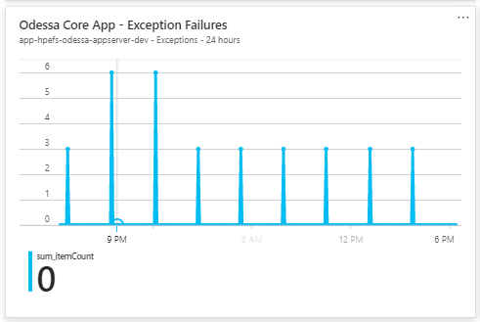

b. Api service flow

* Exception failures
* Operation Failures

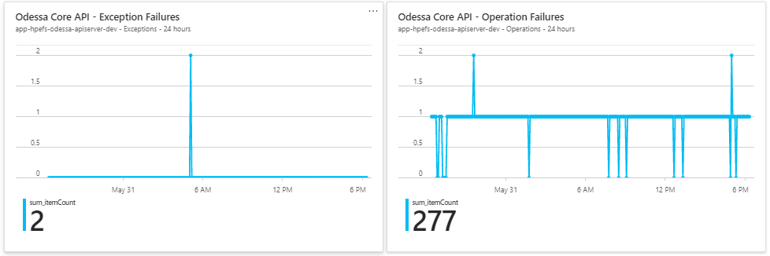

### 9.3.2 Partner Portal

a. App service

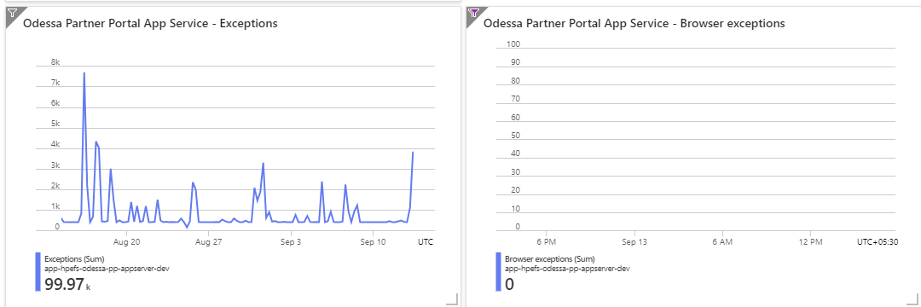

b. Api service

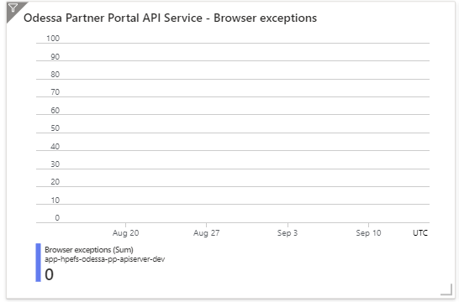

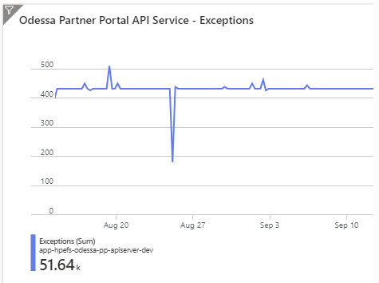

c. Job service

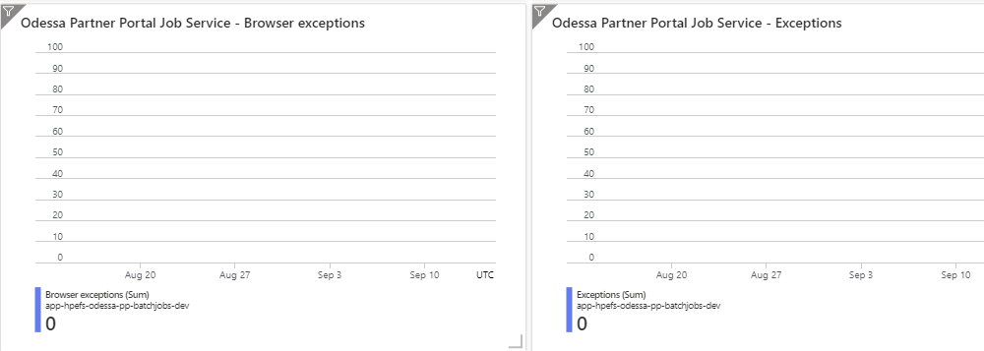

### 9.3.3 Report Builder

1. App service flow

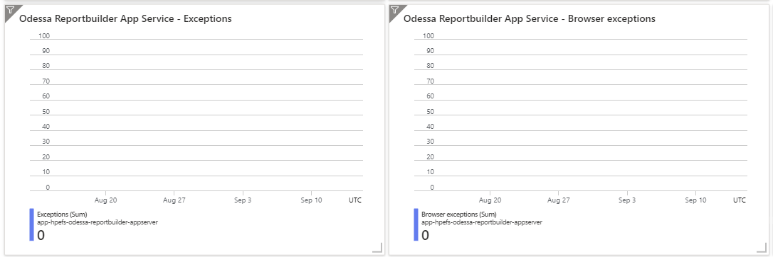

1. Api service flow

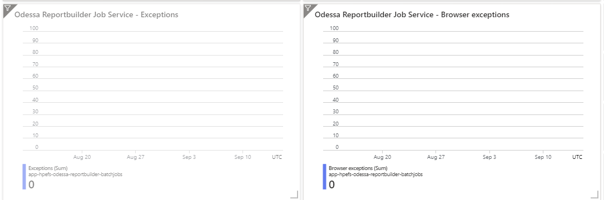

# 10. Application Services - Health Check

Health check pings the configured path on all instances of App Service app at 1-minute intervals. If an instance doesn't respond with a status code between 200-299 (inclusive) after 10 requests, App Service determines it's unhealthy and removes it from the load balancer for this Web App.

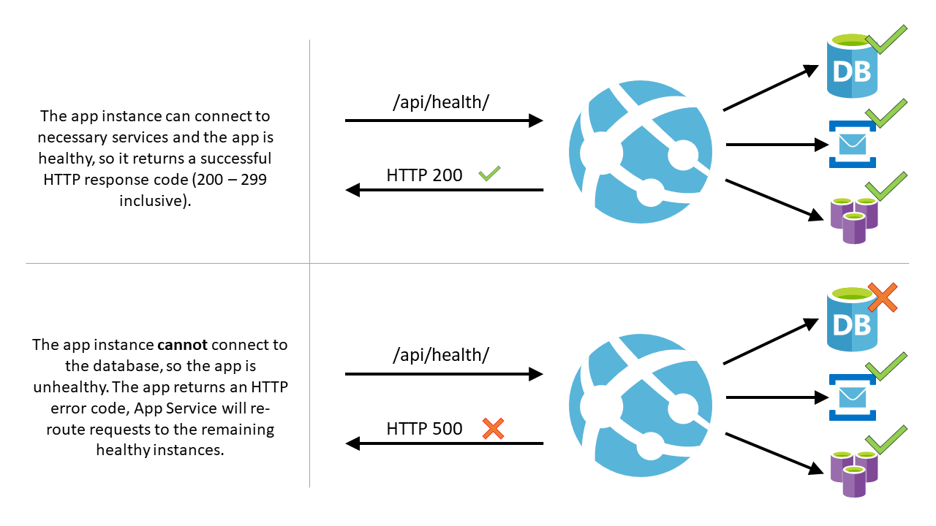

## App Service

Sample example – App service - > search ‘health check’ -> enable the health check -> path (/warmup)

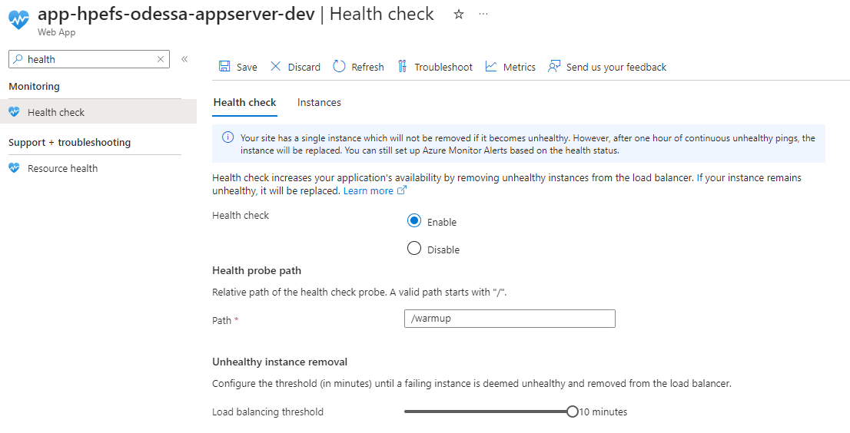

## API Service

Sample example – App service - > search ‘health check’ -> enable the health check -> path (/api/ping)

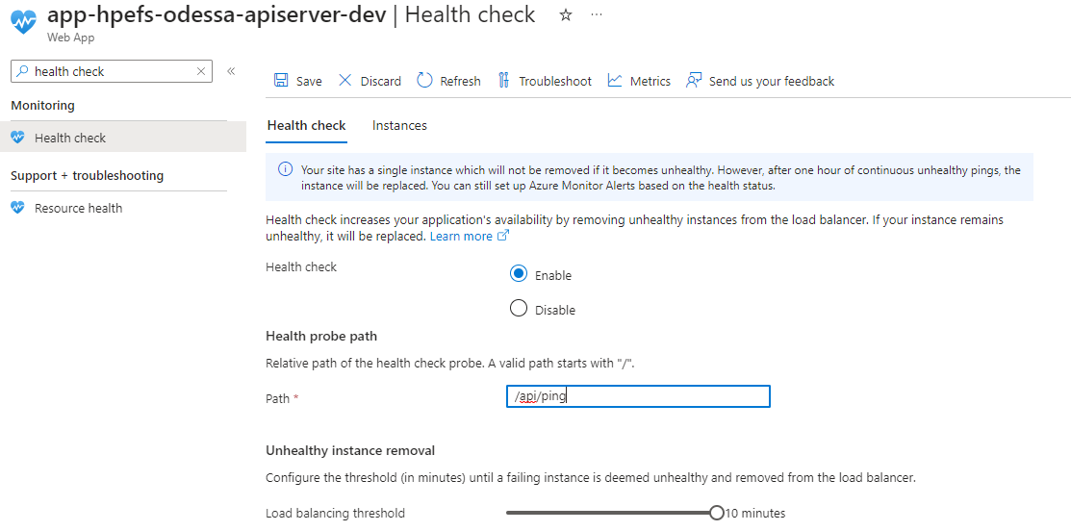

## Batch Jobs Service

Sample example – App service - > search ‘health check’ -> enable the health check -> path (/api/continuouswebjobs/WindowsServices)

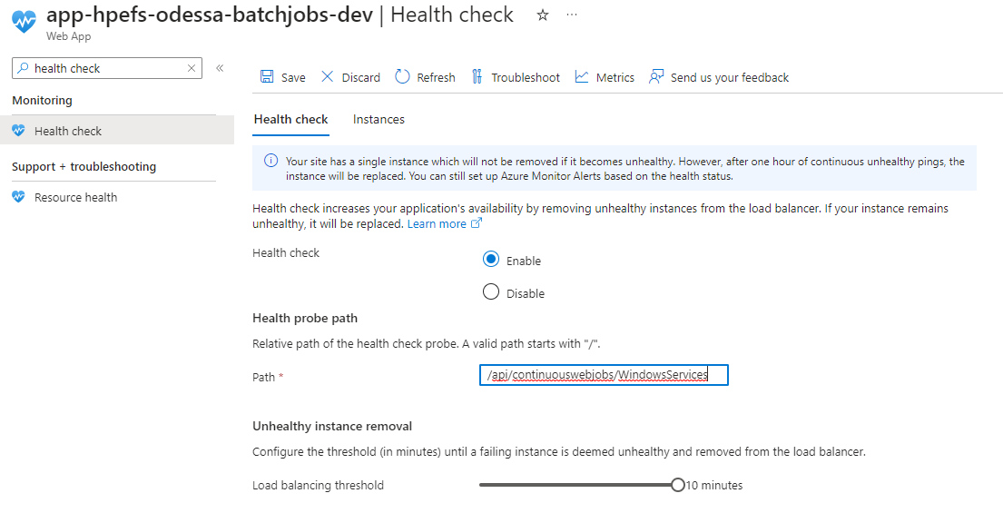

# 11. Reference links

[Private availability testing - Azure Monitor Application Insights - Azure Monitor | Microsoft Learn](https://learn.microsoft.com/en-us/azure/azure-monitor/app/availability-private-test)

[Use Key Vault references - Azure App Service | Microsoft Learn](https://learn.microsoft.com/en-us/azure/app-service/app-service-key-vault-references?tabs=azure-cli)

[How to chart performance with VM insights - Azure Monitor | Microsoft Learn](https://learn.microsoft.com/en-us/azure/azure-monitor/vm/vminsights-performance)

[Azure Monitor Agent overview - Azure Monitor | Microsoft Learn](https://learn.microsoft.com/en-us/azure/azure-monitor/agents/agents-overview)

[Monitor virtual machines with Azure Monitor: Alerts - Azure Monitor | Microsoft Learn](https://learn.microsoft.com/en-us/azure/azure-monitor/vm/monitor-virtual-machine-alerts)

[Create, view, and manage activity log alerts in Azure Monitor - Azure Monitor | Microsoft Docs](https://docs.microsoft.com/en-us/azure/azure-monitor/alerts/alerts-activity-log)